
ADA Plan

Revised for FY 2023

*Please post in each service site on community bulletin board(s)

For more information, questions, or concerns, please contact:

Timothy Dominguez, Risk Manager

361-777-3991

tdominguez@coastalplainsctr.org

Self-Evaluation Checklist

Date June 8, 2023

Persons completing this form:
Name Title
Timothy Dominguez Risk Management Officer - ADA Coordinator

Risk Management (361) 777-3991)
Department Phone Number

Program, Activity or Service: Coastal Plains Community Center

A. List of People Consulted

1. Planning:
- Leo Trejo - Executive Director
- Jonathan Heyward - Adult Mental Health Services Director
- Linda Ramos Perez - Children’s Mental Health Services Director
- Amy Welch - Director of IDD Provider Services
- Joel Perez - Director of IDD Authority Services
- Theresa Guerra - Director of Authority Functions
- Jorge Del los Santos - Director of Quality Management/Privacy Officer
- Timothy Dominguez - Risk Management Director
- Amy Stratton - Rights Officer
- Virginia Delgado HR Director

2. Site Inspection:
- MH Clinic Directors
- Elda Plake - Beeville
- Joel Johnson - Alice
- Stephanie McCoy - Rockport & Aransas Pass
- Amy Pina - Taft
- Mary Zavala - Kingsville, VA Program
- Celina Utley – Falfurrias
- Cynthia Gonzales- San Diego

b. Coordinator of Day Hab Services (CODS) – April Deleon

c. IDD Waiver Services (HCS, TxHmL) - Ruben Garcia – Director

d. YES, Waiver Services – Imelda Barrera - Program Manager

e. TCOOMMI – Salena Hicks – Program Manager

- System of Care – Meagan Blanco – Program Manager

B. Document Preparation: Timothy Dominguez - Director of Risk Management

Jorge De Los Santos – Director of Quality Management Amy Stratton – Client Rights Officer/QA Specialist

C. Implementation: Timothy Dominguez – Director of Risk Management

D. Participation of Disabled Persons
List steps taken to ensure that disabled persons (or their representatives) participate in the completion of this self-evaluation.

The Center utilizes two methods of obtaining customer satisfaction information (please note: All persons receiving services have a disability as defined by ADA) related to services and accessibility.
The Consumers are all provided a “Consumer Rights” handbook at admission and are informed of the accessibility of the Rights Officer. The Rights Officer notifies the Director of Risk Management of any complaints regarding accessibility immediately. There were no complaints made to the rights office over the past 6 years.

This plan will be submitted to the Planning and Network Advisory Committee, which is a group constituted by stakeholders (consumers, family members and community members) for review and approval, prior to submission to the Board of Trustees.

E. Nature of Program
Describe, in general, the nature of the program, including its purpose, scope, general activities and participants.

Coastal Plains Community Center provides services to persons residing in a nine-county geographic service area. The primary consumers of Mental Health Services are those persons identified as priority and target population by HHSC. The primary consumers of Intellectual and Developmental Disability Services are persons identified as having a diagnosis of Intellectual and Developmental Disability as defined by HHSC. For details, refer to the performance contracts for details and eligibility criteria.

Mental Health Services include:
Intake and Assessment
Case Management
Outpatient Psychiatric Services for Adults and Children
Skills Training and Psychosocial Rehab Services
Cognitive Behavioral Therapy
Care Coordination
Supported Housing & Employment Services

Crisis Hotline, Assessments, & Stabilization
TCOOMMI Program - Offenders with Mental Illness Program

PASRR

Respite Services
Family Partner Services

YES Waiver

Veteran’s Services

Peer Provider

Youth & Family Services

Integrated Services include:
Integrated Health Care
Integrated Substance Abuse
Transportation Services

Intellectual and Developmental Disability Services include:
Intake & Assessment
Service Coordination
Home and Community-based Services
Texas Home Living Waiver Services
Individualized Skills and Socialization
Crisis Intervention Services
Community First Choice
Nursing Services
Speech/Language Services
Psychological Services
Respite Care Services
PASRR

F. Recruitment and Advertisement

- Does the public entity engage in any of the following activities to recruit program participants or otherwise inform persons of the program’s existence? If no, proceed to Item E.
The Center is prohibited from advertising for the purpose of soliciting additional external customers. The Center does engage in a public service and educational campaigns designed to inform the general public of the Center’s services and to provide a medium for first contact. The Center utilizes a multi-media approach to negate the impact of single sensory impairment.

Describe briefly activities involved and materials used.

Type of Activity | Steps taken to ensure full participation of people with disabilities
Governance meetings | Board meetings are conducted in public buildings or Center buildings, which meet ADA accessibility requirements.
Brochure/Pamphlets | Statements regarding non-discrimination policy were added to the Center’s primary brochure. This includes information regarding assistance through Texas Relay (TTY Services) for people with hearing impairments.  The majority of the agency pamphlets, brochures and informational material are also published in Spanish.
Public Service Announcements (PSA) | PSA’s are televised with closed caption option for hearing impaired.
Direct staff contact (face to face contacts) | Staff are trained to provide information about services in the language that the person understands. This includes reading materials for people who are unable to read; utilizing interpreters, as needed; assistance in completion of required documentation (including application for services); use of TTY; and home visits as needed.

2. Turn to section “H” (Outside Persons and Organizations) of this checklist. List there any “outside” persons and organizations involved in these recruitment, advertising or information efforts.

See: A through E of Section H

3. Turn to section “I” (Facilities Used). List there all facilities, and parts of facilities, used during recruitment and advertising efforts, including those not owned and/or operated by the public entity (e.g., leased or otherwise used). Are these facilities accessible? IF not, is information available in an accessible location?

See list Section I

G. Program Eligibility Requirements and Admission

1. Are any criteria or tests used in the admission process?

 | No |  | X | Yes
If no, proceed to “7” below.
If yes, list and describe briefly all criteria (e.g., good health, residency requirements, letters of recommendation) and all tests (including the skill, level of achievement, or other factors being tested, whether they are written or oral tests, the method of administration) used in the admissions process, and indicate how they relate to the program.

In order to qualify for IDD services, persons must:

(1) Demonstrate onset of symptoms prior to 18th birthday unless otherwise specified in the contract (e.g. autism spectrum disorders have specific age criteria).
(2) Have full scale IQ below 70 or demonstrate significant deficiencies in adaptive living
(3) DIDD - to establish eligibility

In order to qualify for MH services, persons must:
(1) Member of priority population (as defined by DSMV and/or HHSC)

NOTE: For details on what the specific requirements for “priority population” refer to the Center’s Performance Contracts established by HHSC.

2. List all criteria and tests from “1” above that have (or could have) a disproportionate, adverse impact on disabled program applicants. Discuss briefly the (potential) negative impact for each.

Note: This criterion is utilized to establish disability and does not have a disparate effect.

3. For each criterion or test listed in “2” above that you design and administer, discuss briefly alternative criteria or tests that will be used to ensure non-discrimination. This could include, in limited instances, not using a criterion or test.

N/A

4. For each item listed in “3” above that is designed and/or administered by an “outside” person or organization, list steps to modify any criterion or test that has a (potential) disproportionate, adverse impact on disabled persons, or class(es) of disabled persons (possibly including, in limited instances, not using a criterion or test).

N/A

5. List steps to make potential program participants, including those with hearing and vision impairments and learning disabilities, aware of alternative testing and criteria.

Assessments are conducted by trained/licensed staff, which negates the negative impact of disabilities. As previously stated, these assessments are conducted to establish disability which then qualifies individuals for services. Intake staff is trained to utilize alternative testing/assessment tools to accommodate various disabilities (and to utilize interpretive services necessary to obtain information).

6. Is an interview required before an applicant enters the program?

 | No |  | X | Yes

If no, proceed to “7” below.
If yes, discuss briefly the interview process and list steps to be taken (including the provision of auxiliary aids, as required) to ensure non-discrimination in interviewing.

Interviews are for the purpose of assessment to include identification of disabilities as a justification for program services. Assistance is available for the purpose of providing interpretive services.

7. Are any forms required for admission in the program testing or submission or other admissions criteria?
 | No |  | X | Yes

If no, proceed to “10” below.
If yes, what are the forms, and are any available in alternative formats (e.g., taped, Braille, reader)?

Staff complete all forms.

8. List steps to provide admission forms in alternative formats.

Staff are available as reader. Staff complete applications for consumers.

9. Do the forms listed in “7” above contain a notice of your organization’s compliance with the ADA?
 | No |  | X | Yes

If no, proceed to “10” below.
If yes, list steps to ensure the inclusion of notices of your compliance with the ADA in all materials.

Intake staff give advisory statements which makes potential consumers aware that specialized services are available for disabled persons to facilitate program entry (when being informed of their rights).

10. List steps to ensure applicants are not asked pre-admission inquires as to the nature and extent of a disability and that no forms or other written materials make mandatory inquiries related to disability.

This question is not applicable, as persons must demonstrate a disability to qualify for services. Persons who cannot demonstrate disabilities do not typically meet service requirements with the exception of crisis services.

11. Turn to section “J." List there any “outside” persons and organizations involved in testing, collecting or evaluating admissions criteria.

None

12. Turn to section “K.” List there all facilities and parts of facilities used for testing, collecting or submitting forms and admissions criteria and other activities related to program eligibility requirements, including facilities not owned or operated by the public entity (e.g., leased or otherwise used).

See section I for detailed description of compliance issues by facility location.

H. Participation in the Program

1. Are post-admission inquires made regarding disabled status to make accommodations for disabled persons?

 | No |  | X | Yes

If no, proceed to “2” below.
If yes, list steps to ensure that information is gathered voluntarily, not used to affect any disabled person adversely and kept confidential.

(1) Employment
Information obtained during post hire inquiries is obtained to determine if applicant requires accommodations. This information is maintained in confidential personnel medical record.

(2) Services
All post-admission inquiries are designed to facilitate acquisition of services and eliminate barriers. This information is maintained in confidential client files.

2. Is there an orientation for new participants?

 | No |  | X | Yes

If no, proceed to “3” below.
If yes, describe briefly the orientation and materials used, and list steps to ensure effective communications and usable materials (in alternative formats) for all participants.

Staff provide program orientation. Multilingual and American Sign Language interpreters are available.

3. List below all written materials, tools, equipment or other aids or devices used for the program.

The programs assess consumer’s needs utilizing standardized assessment protocols such as: uniform assessments/TRRs, standardized psychological tests, etc. An application for service is completed which includes intake forms, financial statements, consent forms, medical and psychiatric histories, case management assessment, etc.

4. For each item in “3” above, list steps (e.g., the provision of auxiliary aids, equipment modification) to ensure that program materials and equipment are accessible and usable.

Alternate modalities are utilized for written and visual materials to include readers. Staff are available to make home visits thus negating any transportation needs.

5. Would any steps pose an undue financial or administrative burden?

X | No |  |  | Yes

If yes, list alternative methods of providing accessibility that would not impose an undue financial or administrative burden.

6. What elements or activities are included in the program (e.g., vocational services, music therapy, retirement services, activities of daily living, leisure skills training, supported housing, supported employment, structured recreational and leisure outings, etc.)? All of the above.

7. For each element in “6” above, which ones are, or have the potential to be, inaccessible to disabled participants. Describe steps to make them accessible and usable (e.g., the provision of auxiliary aids, use of alternative materials or formats).

(1) Specialized transportation (wheelchair accessible vans with lifts and tie down straps). Currently utilize transportation services (e.g. Real Transportation.)
(2) Specialized services based upon Individual Plans of Care (e.g. nursing, dietitian, psychological services, etc.)

8. Are any of the following services or benefits provided to program participants (unless already covered in “6” above)? If none is provided, proceed to “9”.

X Transportation Services x Counseling Services
x Employment Services x Health Services and Insurance/Benefits
x Housing x Food Services
x Financial Aid x Social, Recreational or Athletic Activities

List other services provided to program participants.
Medication Services Primary Care Services
Nursing Services Substance Use Services
Psychiatric Services
Case Management

Physician Services

Care Coordination Services

List Steps to ensure that:
Service/benefit is equally effective for and usable by disabled persons;
Administration of service/benefit will be free from discrimination based on disability;
Communications will reach all persons (including those with hearing and sight impairments); and
Effective application procedures to receive the services exist for disabled persons (including those with hearing vision impairments).

It is the function of the interdisciplinary team to determine any specialized accommodations, which are required to maximize service utilization, based upon assessment of each person’s needs. The function of the service coordination/case management unit is to eliminate barriers to services for all recipients both internal and external to the Center. Where needed, readers and language interpretive services are available from the speech therapist unit.

9. List steps to ensure that information concerning program schedules and activities are effectively communicated to all program participants, including those with impaired vision and hearing.

The facility aggressively pursues program participation as this provides the basis of reimbursable services by:
(1) Providing transportation to and from program sites.
(2) Providing case management to include linkage services.
(3) Conducting service satisfaction questionnaires designed to improve participant satisfaction.
(4) Ensuring that notification of scheduled services is provided both orally and in writing

10. Are there boards, councils or similar bodies on which program participants sit?
 | No |  | X | Yes
If no, proceed to “11” below.
If yes, list steps to ensure equal opportunities for selection to, and participation in such boards by disabled persons.

Representation within governing bodies requires consumer/disabled participants or family members/guardians which represent the disabled party.

11. Turn to section “H”. List there any “outside” persons or organizations involved in any aspect of the program.

12. Turn to section “I”. List there all facilities, and parts of facilities, used during the program, including those not owned and/or operated by the recipient (e.g., leased or otherwise used).

13. Are each of these facilities accessible to people with disabilities, including people who use wheelchairs? If not, is the program, “when viewed in its entirety, “accessible”?

 | No |  | X | Yes

If no, what steps will be taken to make it accessible? (If structural changes are necessary for building the public entity owns or operates, this should be documented in the transition plan.)

See transition plan.

I. Staff Information
List steps to ensure that all staff involved in this program (e.g., recruitment, admission, testing, the conduct of the program, the provision of any services or benefits) will be informed periodically of, and understand fully, your policy of non-discrimination on the basis of disability.
(1) Staff are informed at the time of employment of the agency’s policy regarding ADA accommodation.
(2) Staff receive periodic (annual and biannual) training which reaffirms the agency’s participation.
(3) Contracts with providers include the requirement not to discriminate.

J. “Outside” Persons and Organizations

1. List below all “outside” persons and organizations that are involved in the provision of any aid, benefit or service for the program (as discussed in sections “C” through “E” above).
Contracted Services:
Contracts & Procurements ~ Providers
Physicians:
Umamaheswara Maruvada, MD
Krishnaiah Rayasam, MD
Murthy Mangipudi, MD

Psychiatric Hospitals:
Palms Behavioral Health Hospital, Harlingen, TX
Bayview Behavioral Health Hospital, Corpus Christi, TX
South Texas Behavioral Hospital, Edinburg, TX
Doctor’s Hospital at Renaissance, McAllen TX
Laurel Ridge Hospital, San Antonio TX
Oceans Behavioral Hospital, Corpus Christi, TX
Camino Real (Crisis Respite Unit), Lytle, TX
Casa Amistad (Crisis Stabilization Unit), Laredo, TX

Crisis Hotline:
Avail Solutions

Crisis Rehabilitation Services:
Avail Solutions

Crisis Respite Services:
Bluebonnet Trails Crisis Respite Home

Pharmacy and Authorization Services:
East Texas Behavioral Healthcare Network

Substance Abuse Services:
United Connections Counseling

Peer Providers:
2 providers

Family Partners:
3 Community Living Support
2 Music Therapy
1 Equine Therapy
1 Recreational Therapy

Host Home Providers:
29 host home providers

Supported Home Living/ Respite Providers:
46 providers

2. List steps to inform those listed in “1” above of your organization’s commitment to non-discrimination on the basis of disability. Remember that the non-discrimination mandate extends to the awarding of procurement contracts.

Each contract includes the statements that require the contractor not to discrimination on the basis of disability. Contractors are trained at time of engagement and annually refreshed.

3. List those persons and organizations from “1” above that receive “significant assistance” from your organization in the provision of aids, benefits or services to your program participants. (For example, list organizations which rent or otherwise use your facilities; that depend on your organization for informing its participants of the aid, benefit or service; that have employees of your organization spending time to assist in or coordinate the provision of the aid, benefit or service; and so forth.)

NONE

4. List steps to ensure that persons or organizations listed in “3” above do not discriminate on the basis of disability in the provision of any aid, benefit or service to your program participants. (such steps may include changes in the program, facility alternation, and/or changes in or discontinuation of the relationship.)

N/A

I. Facilities Used

(NOTE: The definition of “facility” under the ADA includes all or any portion of buildings, structures, equipment, roads, walks, parking lots or other real or personal property or interest in such property, owned, operated or leased.)

1. List below all facilities, or portions of facilities, used for the activities covered in sections “D” through “F” above, designating for each the activity for which it is used. (NOTE: Facilities leased or otherwise used from another person or organization should be included.)

(a) Taft Clinic
IDD Services: Services for people diagnosed with Intellectual and Developmental Disability Services or other qualifying developmental delays. Includes Service Coordination and the Individualized Skills and Socialization Services (ISS), which is fully accessible. Training is provided on daily living skills with an emphasis on community inclusion. Specialized adaptive equipment for transporting and communicative purposes available. Specialized therapeutic approaches include: speech therapy and vocational therapy.
MH Services: Adult and Children’s Mental Health Clinic provides psychiatric services to persons meeting the HHSC defined MH Population. Fully accessible program – with majority of services provided in vivo. Case Management, psychiatric care, supportive housing, supportive employment, Psychosocial Rehabilitation Program and ACT Alternative services provided.
(b) Rockport Clinic
IDD Services: Services for people diagnosed with Intellectual and Developmental Disability Services or other qualifying developmental delays. Includes Service Coordination and the Individualized Skills and Socialization Services, which is fully accessible. Persons with intellectual disabilities in Aransas County receive services at home or in the Taft clinic (ISS). Transportation is provided on a daily basis during days of operation both ways. Training is provided on daily living skills with an emphasis on community inclusion. Specialized adaptive equipment for transporting and communicative purposes available. Specialized therapeutic approaches include: speech therapy and vocational therapy.
MH Services: Adult and Children’s Mental Health Clinic provides psychiatric services to persons meeting the HHSC defined MH Population. Fully accessible program – with majority of services provided in vivo. Intake and Assessment, Case Management, Medication Clinic, Supportive Housing, Supportive Employment and Psychosocial Rehabilitation Program provided.
(c) Aransas Pass Clinic
IDD Services: Services for people diagnosed with Intellectual and Developmental Disability Services or other qualifying developmental delays. Includes Service Coordination and the Individualized Skills and Socialization Services, which is fully accessible. Persons with intellectual disabilities in Aransas Pass/San Patricio County receive services at home or in the Taft clinic (ISS). Transportation is provided on a daily basis during days of operation both ways. Training is provided on daily living skills with an emphasis on community inclusion. Specialized adaptive equipment for transporting and communicative purposes available. Specialized therapeutic approaches include: speech therapy and vocational therapy.
MH Services: Adult and Children’s Mental Health Clinic provides psychiatric services to persons meeting the HHSC defined MH Population. Fully accessible program – with majority of services provided in vivo. Intake and Assessment, Case Management, Medication Clinic, Supportive Housing, Supportive Employment and Psychosocial Rehabilitation Program provided.

(d) Beeville Clinic
IDD Services: Services for people diagnosed with Intellectual and Developmental Disability Services or other qualifying developmental delays. Includes Service Coordination and the Individualized Skills and Socialization Services, which is fully accessible. Persons with intellectual disabilities in Bee/Live Oak County receive services at home or in the Taft clinic (ISS). Transportation is provided on a daily basis during days of operation both ways. Training is provided on daily living skills with an emphasis on community inclusion. Specialized adaptive equipment for transporting and communicative purposes available. Specialized therapeutic approaches include: speech therapy and vocational therapy.
MH Services: Adult and Children’s Mental Health Clinic provides psychiatric services to persons meeting the HHSC defined MH Population. Fully accessible program – with majority of services provided in vivo. Case Management, supportive housing, supportive employment, Psychosocial Rehabilitation Program and ACT Alternative services provided.
(e) Alice Clinic
IDD Center: Services for people diagnosed with Intellectual and Developmental Disability Services or other qualifying developmental delays. Includes Service Coordination and the Individualized Skills and Socialization Services, which is fully accessible. Training is provided on daily living skills with an emphasis on community inclusion. Specialized adaptive equipment for transporting and communicative purposes available. Specialized therapeutic approaches include: speech therapy and vocational therapy.
MH Services: Adult and Children’s Mental Health Clinic provides psychiatric services to persons meeting the HHSC defined MH Population. Fully accessible program – with majority of services provided in vivo. Intake and Assessment, Service Coordination, Medication Clinic and Assertive Community Treatment (ACT) Alternative services. Psychosocial Rehabilitation Program, Supported Employment and Supportive Housing services provided from a fully accessible site.
(f) Falfurrias Clinic/Center
IDD Services: Services for people diagnosed with Intellectual and Developmental Disability Services or other qualifying developmental delays. Includes Service Coordination and the Individualized Skills and Socialization Services, which is fully accessible. Persons with intellectual disabilities in Brooks County receive services at home or in the Alice clinic (ISS). Transportation is provided on a daily basis during days of operation both ways. Training is provided on daily living skills with an emphasis on community inclusion. Specialized adaptive equipment for transporting and communicative purposes available. Specialized therapeutic approaches include: speech therapy and vocational therapy.
MH Services: Adult and Children’s Mental Health Clinic provides psychiatric services to persons meeting the HHSC defined MH Population. Fully accessible program – with majority of services provided in vivo. Service Coordination, supportive housing, supportive employment and ACT Alternative services provided.
(g) Kingsville Clinic/Center
IDD Services: Services for people diagnosed with Intellectual and Developmental Disability Services or other qualifying developmental delays. Includes Service Coordination and the Individualized Skills and Socialization Services, which is fully accessible. Training is provided on daily living skills with an emphasis on community inclusion. Specialized adaptive equipment for transporting and communicative purposes available. Specialized therapeutic approaches include: speech therapy and vocational therapy.
MH Services: Adult and Children’s Mental Health Clinic provides psychiatric services to persons meeting the HHSC defined MH Population. Fully accessible program – with majority of services provided in vivo. Intake and Assessment, Case Management, Medication Clinic, Supportive Housing, Supportive Employment and Assertive Community Treatment (ACT) program services provided. The Psychosocial Rehabilitation Program, Supported Employment and Supportive Housing services are also provided out of this building.
(h) Portland Office
Administrative: Administrative headquarters includes Service Directors, Authority functions, purchasing, data entry, and some MH and IDD services program managers.
IDD Waiver Services: Headquarters for the HCS, TxHmL and Community First Choice waiver programs for people diagnosed with Intellectual and Developmental Disability Services or Pervasive Developmental Disorders.
YES Waiver: YES, Waiver program headquarters serving children 3-18 years of age with behavioral health diagnosis who are a high risk of out-of-home placement or hospitalizations through case management, skills training, therapies.
(I) San Diego Clinic:
IDD Services: Services for people diagnosed with Intellectual and Developmental Disability Services or other qualifying developmental delays. Includes Service Coordination and the Individualized Skills and Socialization Services, which is fully accessible. Persons with intellectual disabilities in Duval County receive services at home or in the Alice clinic (ISS). Transportation is provided on a daily basis during days of operation both ways. Training is provided on daily living skills with an emphasis on community inclusion. Specialized adaptive equipment for transporting and communicative purposes available. Specialized therapeutic approaches include: speech therapy and vocational therapy.
MH Services: Adult and Children’s Mental Health Clinic provides psychiatric services to persons meeting the HHSC defined MH Population. Fully accessible program – with majority of services provided in vivo. Intake and Assessment, Service Coordination, Medication Clinic and Assertive Community Treatment (ACT) Alternative services. Psychosocial Rehabilitation Program, Supported Employment and Supportive Housing services provided from a fully accessible site.

2. (A) CCPC contractually engaged Estate Registered Accessibility Specialist to conduct an accessibility review utilizing the Texas Accessibility standards 2012 and the 2010 American Disabilities Act accessible guidelines under the Title III requirements. See attached findings.

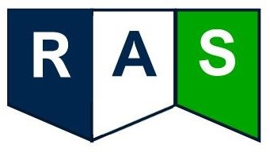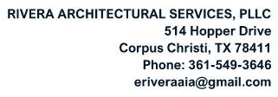

ACCESSBILITY REVIEW OF EXISTING
FACILITIES

Date:
June 18, 2021

Portland, Texas
Marriott Dr.
200

ACCESSIBILITY REVIEW OF EXISTING FACILITIES

Table of Contents

- Executive Summary
  - Purpose of Document
  - Hazardous Materials
  - Supplemental Information
- Accessibility Evaluation Reports
  - Portland Administration Building
  - Taft Service Clinic
  - Aransas Pass Service Clinic
  - Alice Service Clinic
  - San Diego Service Clinic
  - Falfurrias Service Clinic
  - Beeville Service Clinic
- Appendices


Table of Contents
- 1 -

This Page Left Blank


ACCESSIBILITY REVIEW OF EXISTING FACILITIES

1. Executive Summary

1.1 Purpose of Document
Rivera Architectural Services PLLC (RAS-PLLC) inspected the following facilities for the purpose of assisting the board and staff of Coastal Plains Community Center (Coastal Plains) in identifying and recording accessibility deficiencies based on the Texas Accessibility Standards (Standards), 2012 edition, effective March 15, 2012. Care was given to record each deficiency, both written and in photographs, to review and check for compliance with the previous Standards from 1994.
If federal funds are provided for program funding, the elements observed will also be cross checked with both the 1991 and 2010 American Disabilities Act Accessible Guidelines (ADDAG) under Title III requirements.
This report was assembled to assist Coastal Plains in assembling and maintaining a living document focused on accessibility issues that need to be corrected over a period to be determined by the client.
RAS-PLLC cannot serve as the design professional should Coastal Plains determine that one is needed to assist them with correcting the accessibility deficiencies due to this being a conflict of interest.

1.2 Hazardous Materials
The facilities that were visited were not tested for any hazardous materials; this was beyond the scope of work for this report. However, it is recommended that facilities be tested when the date of construction cannot be determined before undertaking any significant renovations either for accessibility compliance or other reasons.

1.3 Supplemental Information
RAS-PLLC reserves the right to supplement this report at any time if new information is provided by the owner and/or state or federal accessibility standards are revised to such a degree that the additional information would warrant inclusion for current and future parties to make better informed decisions on corrective measures.

1.4 Report Format
Each facility is included as an independent report to clearly define the issues at each location. Only the items that are not in compliance are listed. Each report includes the following categories and subcategories listed below. Categories (and subcategories) may be excluded if no deficiencies were observed and recorded.
Summary of Findings:
- Accessible Approach/Accessible Entrance, which includes:
  - Accessible parking and related elements
Executive Summary
- 1 -
  - Accessible curb ramps
  - Accessible entry and related elements
  - Signage
  - Protruding Objects
- Accessible to Goods and Services, which includes:
  - Interior circulation
  - Protruding Objects
  - Interior signage – both room identification and directional
  - Service and Kitchen/Kitchenette Counters
  - Vertical Circulation (Stairs / Lifts / Ramps / Elevators)
- Accessible Restrooms and related elements
  - Water Closet Flush Controls
  - Large Toilet Rooms
  - Single Use Toilet Rooms
- Additional Accessible Elements, which includes:
  - Drinking Fountains
  - Sinks

End of the Executive Summary

2. Accessibility Evaluation Reports

2.1 Portland Administration Building
Facility Location: | 200 Marriott Drive, Portland Texas
Construction Date/Year: | 2008
Occupancy Status (Owner or Lease): | Owner
Accessibility Standards Reviewed:
- 1994 Texas Accessibility Standards (1994 TAS) o Referenced because the building was built prior to 2012.
- 1991 ADAAG (91 ADAAG)
o Referenced because the building was built prior to 2010.
2.1.1 Summary of Findings
No known interior or exterior improvements have occurred in the administration since construction. Accessible elements in the building were reviewed based on the 1994 TAS. The elements below were identified as non-compliant and need to be addressed. Corrections to these items should be done according to the current 2012 Texas Accessibility Standards (2012 TAS).

Accessible Approach / Accessible Entrance
• Parking. There is a total of 70 parking spaces serving the facility. Six of the 70 spaces are designated as accessible according to the pavement markings, but only four have signs. Two are located near the employee entrance. Four spaces are located at the main entry. The minimum number of required spaces is four. More than the minimum amount required is permitted.
- Designate one of the four accessible spaces as van accessible. Provide a “van accessible” sign for the designation.
- Provide an accessible aisle of at least eight feet (8’-0”) in width to the right side of the van accessible space.
- For the remaining accessible spaces, provide an aisle of at least five feet (5’-0”) to one side of the parking space. Accessible parking spaces are permitted to share the accessible aisle(s).
- Stripe each accessible space to comply with TAC 68 Section 68.104. This Section and an example illustration are also attached for reference.
- Provide the correct signage for each parking space.
- The entire signpost at each designated parking space needs to comply with Section 703.1.2 of the 2012 TAS. This section is included in the Appendices of this document.
- Section 502 of the 2012 TAS for parking requirements is included in the Appendices of this document.

Accessible to Goods and Services
- Signage. Provide interior and exterior signs to identify permanent rooms, accessible restrooms and directional signs where necessary.
  - Signs and signs with pictograms shall comply with Section 703 of the 2012 TAS.
This section is included for reference to Provide tactile signs identifying emergency exits
  - Provide tactile signs with the International Symbol of Accessibility to identify accessible restrooms
  - Signs need to be mounted alongside the latch side (locking) side of a single door, where the baseline of the lowest text line is 48 inches maximum or the baseline of the uppermost text line 60 inches above the finished floor to ground level
▪ Mounting instructions for double door or where inadequate space to the latch side of a door occur can be found in Section 703.
  - Provide the International Symbol of Accessibility at the accessible entrance(s) and directional signage complying with Section 703.5 to guide a person to the nearest accessible entrance(s) when not all entrances are accessible.
- Protruding Objects. Elements extending out four inches or more from the wall surface constitute a protruding object. The mail/document collection baskets mounted to the wall by each of the offices do not extend out further than four inches (4”) from the wall therefore are not a violation. However, should a person in a wheelchair become an employee, consider lowering these baskets to within the following reach ranges to make them accessible.
  - Where a forward reach is unobstructed, the high forward reach shall be 48 inches maximum and the low forward reach shall be 15 inches minimum above the finish floor or ground.
  - Where a clear floor or ground space allows a parallel approach to an element and the side reach is unobstructed, the high side reach shall be 48 inches maximum and the low side reach shall be 15 inches minimum above the finish floor or ground
  - If built-in or fixed obstructions are present that cannot readily be moved (such as furniture), please refer to Sections 308 of the 2012 TAS for more information on reach ranges.
  - For a further explanation on protruding objects, refer to Section 307 of the 2012 TAS.
  - If the current basket locations will interfere with the new room identification signs, compliance with the sign mounting requirements should take precedence.

Accessible Restrooms and Related Elements
Per the 1994 TAS, Section 4.1.3 (11) Toilet Facilities: If toilet rooms are provided, then each public and common use (emphasis added) toilet room shall comply with 4.22. Other toilet rooms
provided for the use of occupants of specific spaces (i.e., a private toilet room for the occupant of a private office) shall be adaptable. (Partial statement)
The term “Public Use” and Common Use” are defined as follows under the 1994 TAS.
- Public Use: “Describes interior or exterior rooms or spaces that are made available to the general public. Public use may be provided at a building or facility that is privately or publicly owned”
- Common Use: “Refers to those interior and exterior rooms, spaces, or elements that are made available for the use of a restricted group of people (for example, occupants of a homeless shelter, the occupants of an office building, or the guests of such occupants).”
Based on this Section, all restrooms in the building should have been designed and constructed to be accessible. Each restroom was inspected and the common non-compliant elements are the following:
- Water Closet Flush Controls. Many of the water closet flush controls were not mounted to the wide (open) side of the water closet (side opposite the wall parallel to the bowl).
o the flush controls need to be modified. Either hand operated or automatic controls are permitted. If a lever or paddle type of flush control is provided, then the operating mechanism needs to be placed on the open side of the water closet.
- Grab Bars. Many of the grab bars in the toilet rooms are not compliant with the 1994 TAS. New grab bars need to be provided to comply with the 2012 TAS.
    - The side wall grab bar shall be 42 inches long minimum, located 12 inches maximum from the rear wall and extending 54 inches minimum from the rear wall. (604.5.1 Side Wall.)
    - The rear wall grab bar shall be 36 inches long minimum and extend from the centerline of the water closet 12 inches minimum on one side and 24 inches minimum on the other side. (604.5.2 Rear Wall)
    - Grab bars shall be installed in a horizontal position, 33 inches minimum and 36 inches maximum above the finish floor measured to the top of the gripping surface
- Toilet Tissue Dispensers. Many of the toilet tissue dispensers for the single use restrooms and accessible stall locations are not mounted in the correct position.
      - If new dispensers are being installed, or existing being adjusted, then the space between the grab bar and dispenser mounted below shall be 1 1/2 inches minimum. The space between the grab bar and the dispenser if mounted above the grab bar shall be 12 inches minimum. This is to make sure a person can still access the grab bar without interference.
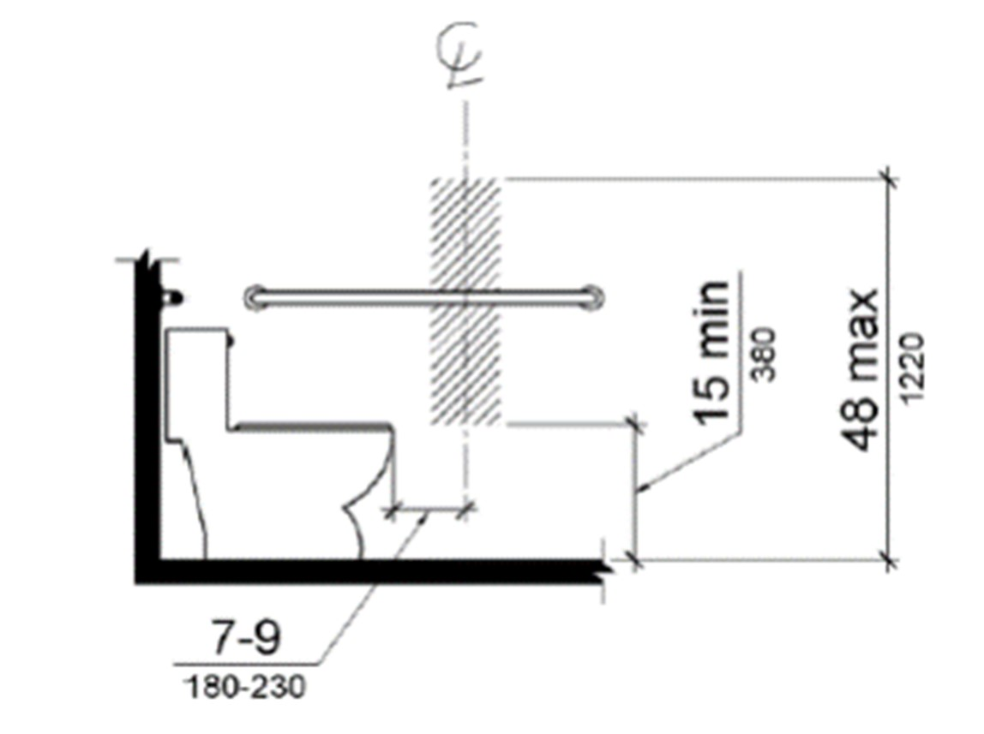
      - Toilet paper dispensers shall comply shall be mounted seven inches minimum and nine inches maximum in front of the water closet measured to the centerline of the dispenser. The outlet of the dispenser shall be 15 inches minimum and 48 inches maximum above the finish floor and shall not be located behind grab bars. The figure on this page illustrates the requirements.
      - The hatched zone in the
figure is the zone for the toilet tissue dispenser outlet location (point where the paper is dispensed). If new dispensers are provided, they must not control delivery or not allow continuous paper flow. If a double roll dispenser is installed, the Standards do not state which outlet needs to be centered as described.
Figure 1 Dispenser outlet location zone

- Mirrors. Many of the restroom mirrors do not comply with the 1994 Standards, which states that the bottom of the reflective surface – not the frame of the mirror - shall be mounted 40 inches maximum above the finished floor. This measurement is the same for the 2012 TAS. The mirrors need to be adjusted so that the mounting height from the finished floor to the bottom of the reflective surface is correct.
  - The 1994 TAS also states that if one mirror is serving the restroom, then it the topmost edge shall measure at least 74 inches high. A mirror that is 36 inches in overall height mounted above a lavatory would meet the topmost edge minimum in the 1994 Standards. The 2012 TAS only advises that the topmost edge measure at a minimum of 74 inches above the finished floor.
  - The 2012 TAS also states that a large, full length mirror mounted on the wall with the bottom of the reflective surface at 35 inches maximum above the finished floor is permitted. If this option is chosen, then it is suggested that the full-length mirror comply with the topmost edge advisement when installed.
- Soap and Paper Towel Dispensers. For these items, the operable parts need to be mounted according to the reach ranges noted under the Protruding Objects section of this report. Operable Parts are defined as: “A part of a piece of equipment or appliance used to insert or withdraw objects, or to activate, deactivate, or adjust the equipment or appliance (for example, coin slot, pushbutton, handle)”. (1994 TAS)
- Lavatories.

o No comments Additional Accessible Elements
• Sinks.
o No comments
End of 2.1 Portland Administration Building Report

2. Accessibility Evaluation Reports

2.2 Taft Service Clinic
Facility Location: | 201 Roots Avenue, Taft TX
Construction Date/Year: | 2000
Occupancy Status (Owner or Lease): | Lease to Purchase
Accessibility Standards Reviewed:
- 1994 Texas Accessibility Standards (1994 TAS) o Referenced because the building was built prior to 2012.
- 1991 ADAAG (91 ADAAG)
o Referenced because the building was built prior to 2010.
2.2.1 Summary of Findings
No known interior or exterior improvements have occurred in the administration since construction. Accessible site and elements in the building were reviewed based on the 1994 TAS. The elements below were identified as non-compliant and need to be addressed. Corrections to these items should be done according to the current 2012 Texas Accessibility Standards (2012 TAS).

Accessible Approach / Accessible Entrance
- Parking. There is a total of 65 angled parking spaces serving the facility. The minimum number of required accessible spaces is three with one designated as van accessible. Angled parking is permissible if the accessible spaces and aisles comply with the width dimensions in the TAS. There are currently four that have been designated as accessible in the past, although they do not comply with either the 1994 or 2012 TAS.
  - Designate at minimum of three spaces as accessible. o Designate one of the three accessible spaces as the van accessible space.
Provide a “van accessible” sign for the designation.
  - Provide an accessible aisle of at least eight feet (8’-0”) in width to the right side of the van accessible space.
  - For the remaining accessible spaces, provide an aisle of at least five feet (5’-0”) to one side of the parking space. Accessible parking spaces are permitted to share the accessible aisle(s).
  - Stripe each accessible space to comply with TAC 68 Section 68.104. This Section and an example illustration are also attached for reference.
  - Provide the correct signage for each parking space.
  - The entire signpost at each designated parking space needs to comply with Section 703.1.2 of the 2012 TAS. This section is included in the Appendices of this document.
  - Section 502 of the 2012 TAS for parking requirements is included in the Appendices of this document.
- Curb Ramps. There are two accessible, though non-compliant, ramps associated with the primary sidewalk serving the first row of angled parking. The ramps resemble a dip in the concrete pavement rather than a correctly formed access ramp.
  - The primary ramp at the foot of the walkway leading to the building has the correct slope in the primary direction of travel.
  - The flares are not distinguishable from the surrounding pavement. The ramp should be outlined in a contrasting color to make is discernible for people with visual impairments.
  - If the furthest ramp will be used to provide accessibility, then the existing ramp should be removed and replaced with one that complies with the current 2012 TAS.

Accessible to Goods and Services
- Signage. Provide interior and exterior signs to identify permanent rooms, accessible restrooms, directional signs where necessary.
  - Signs and signs with pictograms shall comply with Section 703 of the 2012 TAS.
This section is included for reference to Provide tactile signs identifying emergency exits
  - Provide tactile signs with the International Symbol of Accessibility to identify accessible restrooms
  - Signs need to be mounted alongside the latch side (locking) side of a single door, where the baseline of the lowest text line is 48 inches maximum or the baseline of the uppermost text line 60 inches above the finished floor to ground level
▪ Mounting instructions for double door or inadequate room to the latch side of a door scenarios can be found in Section 703.
  - If not, all entrances are accessible, provide the International Symbol of
Accessibility at the accessible entrance(s) and directional signage complying with
Section 703.5 to guide a person to the nearest accessible entrance(s)
- Protruding Objects. Elements extending out four inches or more from the wall surface constitute a protruding object. The mail/document collection baskets mounted to the wall by each of the offices do not extend out further than four inches (4”) from the wall therefore are not a violation. However, should a person in a wheelchair become an employee, consider lowering these baskets to within the following reach ranges to make them accessible.
  - Where a forward reach is unobstructed, the high forward reach shall be 48 inches maximum, and the low forward reach shall be 15 inches minimum above the finish floor or ground.
  - Where a clear floor or ground space allows a parallel approach to an element and the side reach is unobstructed, the high side reach shall be 48 inches maximum, and the low side reach shall be 15 inches minimum above the finish floor or ground
  - If built-in or fixed obstructions are present that cannot readily be moved (such as furniture), please refer to Sections 308 of the 2012 TAS for more information on reach ranges.
  - For a further explanation on protruding objects, refer to Section 307 of the 2012 TAS.
  - If the current basket locations will interfere with the new room identification signs, compliance with the sign mounting requirements should take precedence.
- Service Counters. The service counters at the front desk window extend outward beyond the four-inch limitation for a protruding object given their height without any means below them to be detected by a walking cane. The counters can either be removed and replaced with a piece of furniture to provide the same convenience, or a means that extends to the floor that is detectable can by a walking cane.

Accessible Restrooms and Related Elements
Per the 1994 TAS, Section 4.1.3 (11) Toilet Facilities: If toilet rooms are provided, then each public and common use (emphasis added) toilet room shall comply with 4.22. Other toilet rooms
provided for the use of occupants of specific spaces (i.e., a private toilet room for the occupant of a private office) shall be adaptable. (Partial statement)
The term “Public Use” and Common Use” are defined as follows under the 1994 TAS.
- Public Use: “Describes interior or exterior rooms or spaces that are made available to the general public. Public use may be provided at a building or facility that is privately or publicly owned”
- Common Use: “Refers to those interior and exterior rooms, spaces, or elements that are made available for the use of a restricted group of people (for example, occupants of a homeless shelter, the occupants of an office building, or the guests of such occupants).”
The current assumption is that the facility was built under the 1994 TAS. Based on this Section, all restrooms in the building should have been designed and constructed to be accessible. Each restroom was observed, and the common non-compliant elements are the following:
Public Access (Lobby) Single Use Rooms:
- Water Closets. In the immediate public restrooms, the toilets are installed at the incorrect distance from the walls; greater than the specified range of 16 to 18 inches from the side wall.
- The toilets should be adjusted to the correct distance from the wall to make them accessible. If completely replaced, the seat height must be between 17 and 19 inches in height.
- If the walls of the restroom are adjusted instead of the toilets, then the width of the room must remain at least 60 minimum clear to maintain a turning space for a wheelchair.
- Water Closet Flush Controls. The water closet flush control in the men’s restroom is on the incorrect side of the tank. The flush control needs to be on the open side of the toilet.
o the flush controls need to be modified. Either hand operated or automatic controls are permitted. If a lever or paddle type of flush control is provided, then
the operating mechanism needs to be placed on the open side of the water closet.
Common Use Restrooms:
- Water Closets. Toilets in the three common use restrooms do not have the correct seat height of 17 to 19 inches above the finished floor level.
- It is recommended that the toilet in the largest restroom be replaced, with the flush controls to the open side of the toilet and the seat height within the range noted above.
- Urinal. Transforming the largest restroom into an accessible restroom will require removing the urinal because a plumbing fixture or any other obstruction cannot be within the clear floor space of the toilet per the 2012 TAS. (Section 604.3.2) Common Restroom Elements:
- Grab Bars. Many of the grab bars in the toilet rooms are not compliant with the 1994 TAS. New grab bars need to be provided to comply with the 2012 TAS.
    - The side wall grab bar shall be 42 inches long minimum, located 12 inches maximum from the rear wall and extending 54 inches minimum from the rear wall. (604.5.1 Side Wall.)
    - The rear wall grab bar shall be 36 inches long minimum and extend from the centerline of the water closet 12 inches minimum on one side and 24 inches minimum on the other side. (604.5.2 Rear Wall)
    - Grab bars shall be installed in a horizontal position, 33 inches minimum and 36 inches maximum above the finish floor measured to the top of the gripping surface
    - Toilet Tissue Dispensers. Many of the toilet tissue dispensers for the single use restrooms are not mounted in the correct position.
if new dispensers are being installed, or existing being adjusted, then the space between the grab bar and dispenser mounted below shall be 1 1/2 inches minimum. The space between the grab bar and the dispenser if mounted above the grab bar shall be 12 inches minimum. This is to make sure a person can still access the grab bar without interference.

      - Toilet paper dispensers shall comply shall be mounted seven inches minimum and nine inches maximum in front of the water closet measured to the centerline of the dispenser. The outlet of the dispenser shall be 15 inches minimum and 48 inches maximum above the finish floor and shall not be located behind grab bars. The figure on this page illustrates the requirements.
      - The hatched zone in the
figure is the zone for the toilet tissue dispenser outlet location (point where the paper is dispensed). If new dispensers are provided, they must not control delivery or not allow continuous paper flow. If a double roll dispenser is installed, the Standards do not state which outlet needs to be centered as described.
Figure 1 Dispenser outlet location zone

- Mirrors. Many of the restroom mirrors do not comply with the 1994 Standards, which states that the bottom of the reflective surface – not the frame of the mirror - shall be mounted 40 inches maximum above the finished floor. This measurement is the same for the 2012 TAS. The mirrors need to be adjusted so that the mounting height from the finished floor to the bottom of the reflective surface is correct.

  - The 1994 TAS also states that if one mirror is serving the restroom, then it the topmost edge shall measure at least 74 inches high. A mirror that is 36 inches in overall height mounted above a lavatory would meet the topmost edge minimum in the 1994 Standards. The 2012 TAS only advises that the topmost edge measure at a minimum of 74 inches above the finished floor.
  - The 2012 TAS also states that a large, full length mirror mounted on the wall with the bottom of the reflective surface at 35 inches maximum above the finished floor is permitted. If this option is chosen, then it is suggested that the full-length mirror comply with the topmost edge advisement when installed.

- Soap and Paper Towel Dispensers. For these items, the operable parts need to be mounted according to the reach ranges noted under the Protruding Objects section of this report. Operable Parts are defined as: “A part of a piece of equipment or appliance used to insert or withdraw objects, or to activate, deactivate, or adjust the equipment or appliance
(for example, coin slot, pushbutton, handle)”. (1994 TAS, 3.5.40)
- Lavatories. The exposed piping of the wall hung lavatories in the restrooms are not protected as required. The drainpipe, water lines and valves must be protected as required both in the 1994 and 2012 TAS.

Additional Accessible Elements
- Sinks.
  - No comments
- Abandoned Floor Drains. The floor drains that are no longer used need to be covered or filled to provide a smooth floor surface.
- Emergency Exit(s). The emergency exits of the building do not have the correct clear floor space for a forward approach to the door.
  - The 1994 TAS state that: “4.1.3(8)(ii) Accessible entrances and exits must be provided in a number and at locations at least equivalent to the total number and locations of exits required by the applicable building/fire codes, including accessible routes. Refer to 4.1.3(9) where conditions preclude accessible exits.” (1994 TAS,
Partial statement) o All exit doors do not meet the forward approach clearance. Where the door swing can be changed, the door needs to be reversed so that the latch side of the door has the correct clearance for a forward approach, which is 12 inches minimum. The exit door(s) must still swing outward. See the figure below for the floor clearance requirements (from 2012 TAS, Section 404.2.4.1).
  - The outside landing at the exit will need to be modified so that the finished floor level is the same as the interior floor. The slope in the direction of travel in the landing shall not exceed 1:20.
  - The door threshold shall also be modified so that the height is not greater than 1/2 of an inch.
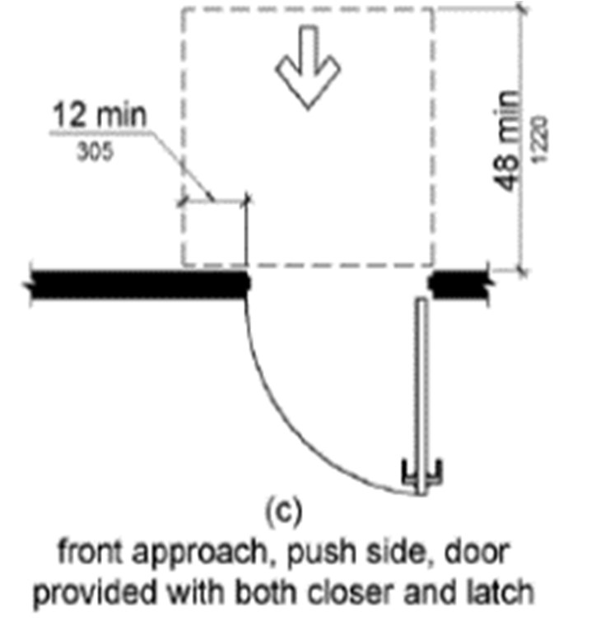

End of 2.2 Taft Service Clinic Report

Accessibility Evaluation Reports

2.3 Aransas Pass Service Clinic
Facility Location: | 1008, 1010, 1012 S. Commercial, Aransas Pass, TX
Construction Date/Year: | Unknown for building
Occupancy Status (Owner or Lease): | Lease
Accessibility Standards Reviewed:
- 1994 Texas Accessibility Standards (1994 TAS) o Referenced because the building was built prior to 2012.
- 1991 ADAAG (91 ADAAG)
o Referenced because the building was built prior to 2010.

2.3.1 Summary of Findings
The interior lease space has seen some interior expansion. Accessible elements in the original lease space were reviewed based on the 1994 TAS while the new acquired lease was reviewed based on the 2012 TAS. The elements below were identified as non-compliant and need to be addressed. Corrections to these items should be done according to the current 2012 Texas Accessibility Standards (2012 TAS).

Accessible Approach / Accessible Entrance
- Parking. There is a total of 21 angled parking spaces serving the office facility. The minimum number of required accessible spaces is two with one designated as van accessible. There are currently two that have been designated as accessible for the office facility. Angled parking is permissible if the accessible spaces and aisles comply with the width dimensions in the TAS. Because of presumed lease agreement limitations in addressing the site concerns, the client is encouraged to comply to the maximum extent possible.
  - There is an access aisle provided directly in front of the Coastal Plains office entrance. The parking space to the left of the aisle can be designated as the accessible van accessible space. Provide an “accessible parking” sign and “van accessible” sign for the designation.
  - Verify that the accessible aisle is at least eight feet (8’-0”) in width to the right side of the van accessible space.
  - Stripe the van accessible space and aisle to comply with TAC 68 Section 68.104.
This Section and an example illustration are also attached for reference.
  - If a new signpost is provided, then it needs to comply with Section 703.1.2 of the 2012 TAS. This section is included in the Appendices of this document.
  - Section 502 of the 2012 TAS for parking requirements is included in the Appendices of this document.
- Curb Ramps. There are two accessible, built up curb ramps associated with the primary sidewalk serving the first row of angled parking.
  - The ramp for the van accessible space in the immediate proximity to the clinic’s entrance measures a 9.25% slope, which is steeper than 1:12 (8.3%). The ramp is a site related issue. It is recommended that the building owner be approached about correcting the ramp to comply with the current 2012 TAS.
  - Only the ramp closest to the clinic’s entrance was inspected. Accessible to Goods and Services
- Signage. Provide interior and exterior signs to identify permanent rooms, accessible restrooms, directional signs where necessary.
  - Signs and signs with pictograms shall comply with Section 703 of the 2012 TAS.
This section is included for reference
o Provide tactile signs identifying emergency exits
  - Provide tactile signs with the International Symbol of Accessibility to identify accessible restrooms
  - Signs need to be mounted alongside the latch side (locking) side of a single door, where the baseline of the lowest text line is 48 inches maximum or the baseline of the uppermost text line 60 inches above the finished floor to ground level
▪ Mounting instructions for double door or inadequate room to the latch side of a door scenarios can be found in Section 703.
o Provide the International Symbol of Accessibility at the accessible entrance(s) and directional signage complying with Section 703.5 to guide a person to the nearest accessible entrance(s) if not all entrances are accessible,
- Protruding Objects. Elements extending out four inches or more from the wall surface constitute a protruding object. The mail/document collection baskets mounted to the wall by each of the offices do not extend out further than four inches (4”) from the wall therefore are not a violation. However, should a person in a wheelchair become an employee, consider lowering these baskets to within the following reach ranges to make them accessible.
  - Where a forward reach is unobstructed, the high forward reach shall be 48 inches maximum, and the low forward reach shall be 15 inches minimum above the finish floor or ground.
  - Where a clear floor or ground space allows a parallel approach to an element and the side reach is unobstructed, the high side reach shall be 48 inches maximum, and the low side reach shall be 15 inches minimum above the finish floor or ground
  - If built-in or fixed obstructions are present that cannot readily be moved (such as furniture), please refer to Sections 308 of the 2012 TAS for more information on reach ranges.
  - For a further explanation on protruding objects, refer to Section 307 of the 2012 TAS.
  - If the current basket locations will interfere with the new room identification signs, compliance with the sign mounting requirements should take precedence.
- Service Counters. The service counters at the front desk window extend outward beyond the four-inch limitation for a protruding object given their height without any means below them to be detected by a walking cane. The counters can either be removed and replaced with a piece of furniture to provide the same convenience, or a means that extends to the floor so that the counter is detectable can be installed. Accessible Restrooms
Per the 1994 TAS, Section 4.1.3 (11) Toilet Facilities: If toilet rooms are provided, then each public and common use (emphasis added) toilet room shall comply with 4.22. Other toilet rooms provided for the use of occupants of specific spaces (i.e., a private toilet room for the occupant of a private office) shall be adaptable. (Partial statement)
The term “Public Use” and Common Use” are defined as follows under the 1994 TAS.
- Public Use: “Describes interior or exterior rooms or spaces that are made available to the general public. Public use may be provided at a building or facility that is privately or publicly owned”
- Common Use: “Refers to those interior and exterior rooms, spaces, or elements that are made available for the use of a restricted group of people (for example, occupants of a homeless shelter, the occupants of an office building, or the guests of such occupants).”
The current assumption is that the facility was built under the 1994 TAS. Based on this Section, all original restrooms in the building should have been designed and constructed to be accessible. Restrooms added in the expansion of the clinic should have been constructed to the 2012 TAS if completed after March of 2012. Each restroom was inspected, and the common non-compliant elements are the following:
Single Use/Unisex Restrooms:
- Psychiatric Clinic Area: This employee only designated restroom is not accessible. The restroom is not large enough to be updated without enlarging the restroom.
- Nurse’s Examination Area: There are two single use restrooms that are part of the original lease space that are not accessible.
  - Women’s restroom: This restroom has two stalls; one open that has been adapted for accessibility and one small stall. The is restroom is not compliant with either the 1994 or 2012 TAS. This restroom may have enough room to be remodeled into a single unisex/accessible restroom for the clinic.
  - Men’s restroom: This restroom has one water closet and one urinal. The is restroom is not compliant with either the 1994 or 2012 TAS.
- Case Manager’s Employee Restroom: This restroom has a single water closet and a pedestal mounted lavatory installed right along the latch side of the restroom door. The room is large enough to be remodeled into an accessible restroom. However, the water closet is mounted too close (less than 16 inches) to the parallel wall and would have to be relocated.
- Lease Addition: There are two restrooms in this new area of the facility.
  - The men’s restroom is a single use restroom with a wall mounted lavatory, urinal and toilet. This restroom is accessible.
  - The women’s restroom has two partitioned toilet stalls, one that is accessible and a wall mounted lavatory. Related Restroom Elements
- Stall Partitions. Stall partitions need to have the following clear floor space if the partition door swings outward, as the current stall is arranged. The current women’s restroom in the lease addition area are installed too close to the restroom door. The stall depths can be changes so that the accessible stall complies with the following clearances:
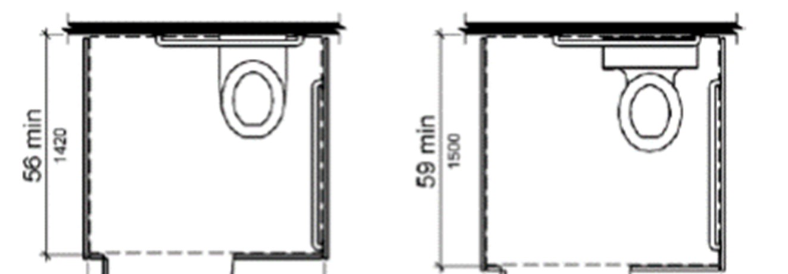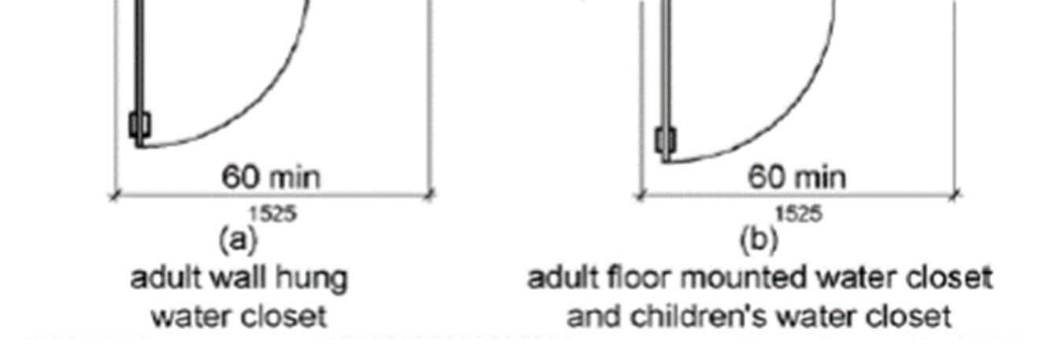
- Water Closet Flush Controls. Accessible restroom toilet(s) shall have the flush control on the open of the toilet bowl. The replacement controls can be either hand operated or automatic. If hand operated, then the lever or paddle must be placed on the open side of the water closet.
- Grab Bars. New grab bars shall comply in restrooms that will be modified to meet the 2012 standards.
  - The side wall grab bar shall be 42 inches long minimum, located 12 inches maximum from the rear wall and extending 54 inches minimum from the rear wall. (604.5.1 Side Wall.)
  - The rear wall grab bar shall be 36 inches long minimum and extend from the centerline of the water closet 12 inches minimum on one side and 24 inches minimum on the other side. (604.5.2 Rear Wall)
  - Grab bars shall be installed in a horizontal position, 33 inches minimum and 36 inches maximum above the finish floor measured to the top of the gripping surface

- Toilet Tissue Dispensers. The toilet tissue dispensers for the restrooms need to comply with the following:
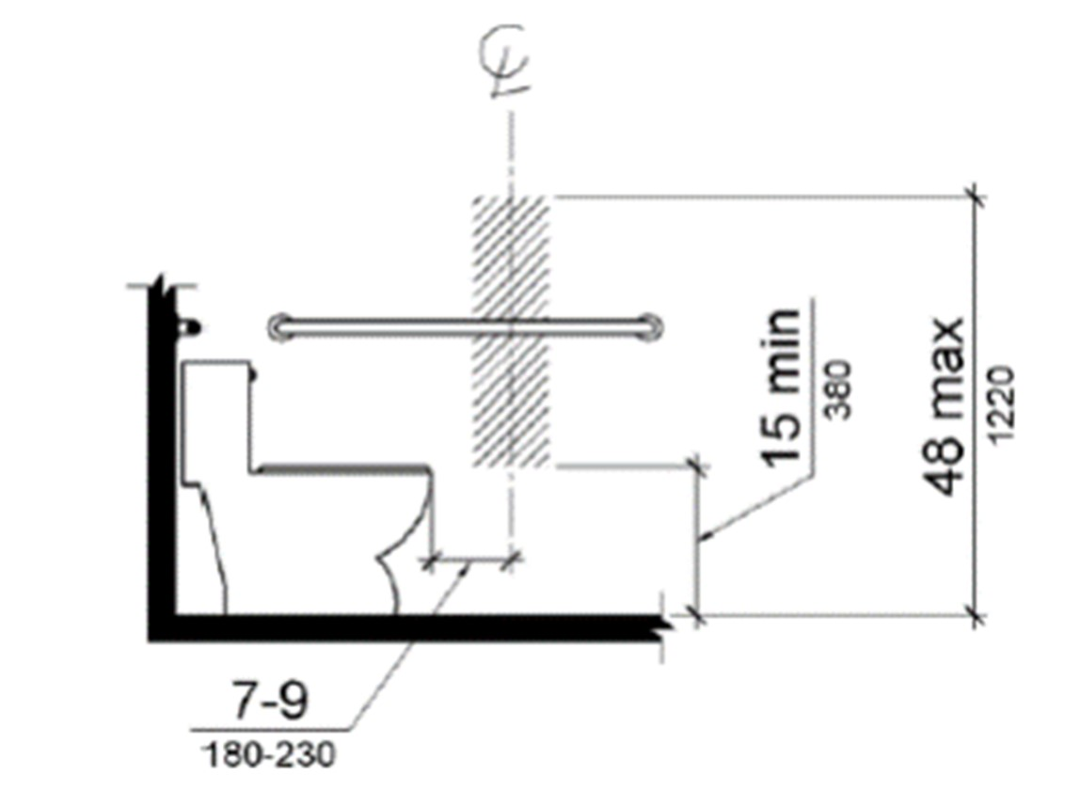

Figure 1 Dispenser outlet location zone

  - If new dispensers are being installed, or existing being adjusted, then the space
between the grab bar and dispenser mounted below shall be 1 1/2 inches minimum. The space between the grab bar and the dispenser if mounted above the grab bar shall be 12 inches minimum. This is to make sure a person can still access the grab bar without interference.
- Toilet paper dispensers shall comply shall be mounted seven inches minimum and nine inches maximum in front of the water closet measured to the centerline of the dispenser. The outlet of the dispenser shall be 15 inches minimum and 48 inches maximum above the finish floor and shall not be located behind grab bars. The figure on this page illustrates the requirements.
        - The hatched zone in the figure is the zone for the toilet tissue dispenser
outlet location (point where the paper is dispensed). If new
dispensers are provided, they must not control delivery or not allow
continuous paper flow. If a double roll dispenser is installed, the Standards do not state which outlet needs to be centered as described.
- Mirrors. The restroom mirrors need to be mounted so the bottom of the reflective surface – not the frame of the mirror - is mounted 40 inches maximum above the finished floor. This measurement is the same in both the 1994 and the 2012 TAS. The mirrors need to be adjusted so that the mounting height from the finished floor to the bottom of the reflective surface is correct.
o the 2012 TAS also states that a large, full length mirror mounted on the wall with the bottom of the reflective surface at 35 inches maximum above the finished floor is permitted. If this option is chosen, then it is suggested that the full-length mirror comply with the topmost edge advisement when installed.
- Soap and Paper Towel Dispensers. For these items, the operable parts need to be mounted according to the reach ranges noted under the Protruding Objects section of this report. Operable Parts are defined as: “A part of a piece of equipment or appliance used to insert or withdraw objects, or to activate, deactivate, or adjust the equipment or appliance
(for example, coin slot, pushbutton, handle)”. (1994 TAS)
- Lavatories. The exposed piping of the wall hung lavatories in the restrooms are not protected as required. The drainpipe, water lines and valves must be protected as required both in the 2012 TAS.

Additional Accessible Elements
- Coat Hooks. Where coat hooks are provided, such as in a restroom stall or any wall, they must not extend outward more than four inches to avoid being a protruding object. In addition, if one or more is provided in any location, then at least one shall be mounted at 48 inches maximum in height to be accessible.
- Break Room Counter Sinks. Break room counters that contain a sink must be accessible by providing the required knee clearance under the sink for a forward approach. The exposed piping must be protected as the lavatory piping is by either a shield or insulation to cover or wrap the piping, water lines and valves respectfully. The current counters do not provide the required knee space.
- Sinks.
o No comments.

End of 2.3 Aransas Pass Service Clinic Report

Accessibility Evaluation Reports

2.4 Alice Service Clinic
Facility Location: | 614 W. Front St., Alice TX
Construction Date/Year: | 2008
Occupancy Status (Owner or Lease): | Owner
Accessibility Standards Reviewed:
- 1994 Texas Accessibility Standards (1994 TAS) o Referenced because the building was built prior to 2012.
- 1991 ADAAG (91 ADAAG)
o Referenced because the building was built prior to 2010.
2.4.1 Summary of Findings
Accessible site and building elements were reviewed based on the 1994 TAS. The elements below were identified as non-compliant and need to be addressed. Corrections to these items should be done according to the current 2012 Texas Accessibility Standards (2012 TAS).

Accessible Approach / Accessible Entrance
• Parking.
o No comments.

Accessible to Goods and Services
- Signage. Provide interior and exterior signs to identify permanent rooms, accessible restrooms, and directional signs where necessary.
    - Signs and signs with pictograms shall comply with Section 703 of the 2012 TAS.
This section is included for reference to Provide tactile signs identifying emergency exits
    - Provide tactile signs with the International Symbol of Accessibility to identify accessible restrooms
    - Signs need to be mounted alongside the latch side (locking) side of a single door, where the baseline of the lowest text line is 48 inches maximum or the baseline of the uppermost text line 60 inches above the finished floor to ground level
▪ Mounting instructions for double door or inadequate room to the latch side of a door scenarios can be found in Section 703.
- Protruding Objects. Elements extending out four inches or more from the wall surface constitute a protruding object. The mail/document collection baskets mounted to the wall by each of the offices do not extend out further than four inches (4”) from the wall therefore are not a violation. However, should a person in a wheelchair become an employee, consider lowering these baskets to within the following reach ranges to make them accessible.
    - Where a forward reach is unobstructed, the high forward reach shall be 48 inches (1220 mm) maximum and the low forward reach shall be 15 inches (380 mm) minimum above the finish floor or ground.
    - Where a clear floor or ground space allows a parallel approach to an element and the side reach is unobstructed, the high side reach shall be 48 inches (1220 mm) maximum and the low side reach shall be 15 inches (380 mm) minimum above the finish floor or ground
    - If built-in or fixed obstructions are present that cannot readily be moved (such as furniture), please refer to Sections 308 of the 2012 TAS for more information on reach ranges.
    - For a further explanation on protruding objects, refer to Section 307 of the 2012 TAS.
    - If the current basket locations will interfere with the new room identification signs, compliance with the sign mounting requirements should take precedence. Accessible Restrooms and Related Elements
Per the 1994 TAS, Section 4.1.3 (11) Toilet Facilities: If toilet rooms are provided, then each public and common use (emphasis added) toilet room shall comply with 4.22. Other toilet rooms provided for the use of occupants of specific spaces (i.e., a private toilet room for the occupant of a private office) shall be adaptable. (Partial statement)
The term “Public Use” and Common Use” are defined as follows under the 1994 TAS.
- Public Use: “Describes interior or exterior rooms or spaces that are made available to the general public. Public use may be provided at a building or facility that is privately or publicly owned”
- Common Use: “Refers to those interior and exterior rooms, spaces, or elements that are made available for the use of a restricted group of people (for example, occupants of a homeless shelter, the occupants of an office building, or the guests of such occupants).”
Based on this Section, all original restrooms in the building should have been designed and constructed to be accessible. Restrooms added in the expansion of the clinic should have been constructed to the 2012 TAS if completed after March of 2012. Each restroom was observed, and the common non-compliant elements are the following:
- Toilet Tissue Dispensers. Many of the toilet tissue dispensers for the single use restrooms simply need to be checked and corrected as necessary according to the guidelines below:

If new dispensers are being installed, or existing being adjusted, then the space between the grab bar and dispenser mounted below shall be 1 1/2 inches minimum. The space between the

Figure 1 Dispenser outlet location zone

grab bar and the dispenser if mounted above the grab bar shall be 12 inches minimum. This is to make sure a person can still access the grab bar without interference.
- Toilet paper dispensers shall comply shall be mounted seven inches minimum and nine inches maximum in front of the water closet measured to the centerline of the dispenser. The outlet of the dispenser shall be 15 inches minimum and 48 inches maximum above the finish floor and shall not be located behind grab bars. The figure on this page illustrates the requirements.
- The hatched zone in the
figure is the zone for the toilet tissue dispenser outlet location (point where the paper is dispensed). If new dispensers are provided, they must
not control delivery or not allow continuous paper flow. If a double roll dispenser is installed, the Standards do not state which outlet needs to be centered as described.
- Mirrors.
  - No comments.
- Paper Towel Dispensers. For these items, the operable parts need to be mounted according to the reach ranges noted under the Protruding Objects section of this report. Operable Parts are defined as: “A part of a piece of equipment or appliance used to insert or withdraw objects, or to activate, deactivate, or adjust the equipment or appliance (for example, coin slot, pushbutton, handle)”. (1994 TAS)
- o the recessed paper towel and trash combination units in the restrooms are mounted too high in the wall. The point of towel delivery needs to be 48 inches maximum above the finished floor.
▪ A new, surface mounted towel dispenser can be installed to correct this issue so one in each restroom is accessible.
- Lavatories.
  - No comments.

Additional Accessible Elements
• Sinks. A side approach to the kitchen sink is permissible. However, consideration should be given to adjusting and protecting the exposed pipes to meet the required knee space, so the sink’s accessibility is increased.

End of 2.4 Alice Service Clinic Report

Accessibility Evaluation Reports

2.5 San Diego Service Clinic
Facility Location: | 409 E. Gravis, San Diego, TX
Construction Date/Year: | 2020
Occupancy Status (Owner or Lease): | Owner
Accessibility Standards Reviewed:
- 2012 Texas Accessibility Standards (2012 TAS)
- 2010 ADAAG
2.5.1 Summary of Findings
Accessible site and building elements were reviewed based on the 2012 TAS. The elements below were identified as non-compliant and need to be addressed. Corrections to these items should be done according to the current 2012 Texas Accessibility Standards (2012 TAS).

Accessible Approach / Accessible Entrance
- Parking. There is a total of 13 parking spaces serving the clinic that are discernable. The minimum number of required accessible spaces is one. The one designated space shall be a van accessible space.
  - Provide the required accessible parking and van accessible signs for designation.
  - The current accessible space can be used as the van accessible space.
  - The entire signpost needs to comply with Section 703.1.2 of the 2012 TAS. This section is included in the Appendices of this document.
  - The pavement markings need to be brought into compliance with the revisions made to 68 Section 68.104. This Section and an example illustration are also attached for reference.
  - Wheel stops are not required. However, one may aid in preventing someone from running into the accessible parking signpost with their vehicle.
- Curb Ramps. The first seven feet (7’-0”) of the walkway leading to the entrance door is at a slope of 1:10 (10%), which is greater that the slope permitted for a ramp. An accessible ramp shall have a slope of 1:12 (8-8.3%) and handrails on both sides if it extends beyond six feet (6’-0”). The remainder of the walkway beyond the first seven feet extending to the front door landing varies in slope from 4.70% to 6.10%. The permitted running slope for a walkway is no greater than 5% (1:48).
  - It is recommended that the full approach be replaced so that the running slopes are not greater than 5% from the ramp adjustment.
  - Or an alternate means of approach can be designed to comply to avoid extensive demolition. If this approach is chosen, it is recommended that a survey be performed to determine the existing grade elevations so an alternate, compliant approach can be designed and constructed correctly.

Accessible to Goods and Services
- Signage. Provide interior and exterior signs to identify permanent rooms, accessible restrooms, and directional signs where necessary.
  - Signs and signs with pictograms shall comply with Section 703 of the 2012 TAS.
This section is included for reference to Provide tactile signs identifying emergency exits
  - Provide tactile signs with the International Symbol of Accessibility to identify accessible restrooms
  - Signs need to be mounted alongside the latch side (locking) side of a single door, where the baseline of the lowest text line is 48 inches maximum or the baseline of the uppermost text line 60 inches above the finished floor to ground level
▪ Mounting instructions for double door or inadequate room to the latch side of a door scenarios can be found in Section 703.
- Protruding Objects. o No comments. • Service Counters.
  - No comments.

Accessible Restrooms and Related Elements
Per the 2012 TAS, Section 213.2 Toilet Rooms and Bathing Rooms- Where toilet rooms are provided, each toilet room shall comply with [Section] 603. Where bathing rooms are provided, each bathing room shall comply with 603.
Based on this Section, all restrooms in the building should have been designed and constructed to be accessible. Each restroom was observed, and the common non-compliant elements are the following:
- Toilet Tissue Dispensers.
  - No comments
- Mirrors.
  - No comments
- Paper Towel Dispensers.
  - No comments
- Lavatories and Sinks. The restroom lavatories are located within the required clear floor space of the water closets. No plumbing fixtures are permitted within the 60-inch square clear floor space of a water closet.
  - The lavatories can be shifted away from the water closets from current locations to comply.
  - Relocating the lavatories within the restrooms is an option. If relocated, abide by the required knee clearance, provide the correct forward approach clear floor space (see figure below) the rim of the lavatory is not higher than 34 inches from the finished floor, and the exposed pipes below are protected by a shield or insulated.

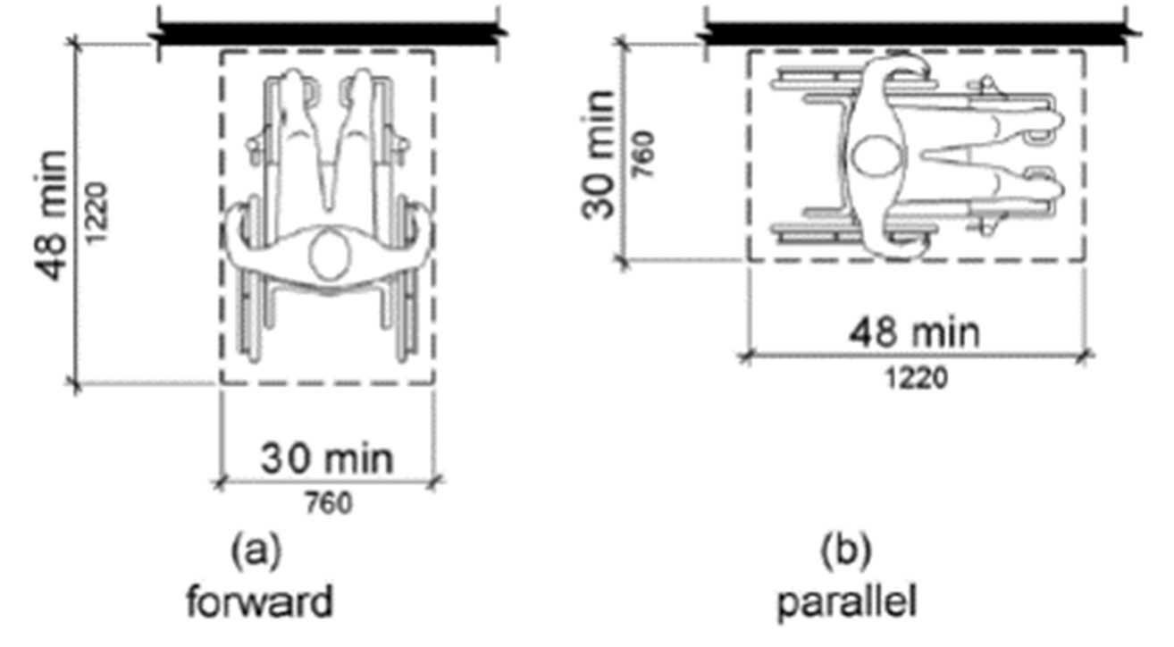
Figure 1-The required forward and/or parallel approach clear floor spaces

Additional Accessible Elements
- Fire Extinguisher Cabinets. The cabinet handles (operable parts) are located more than 60 inches from the finished floor.
- All cabinets should be relocated so that the cabin handles are within the reach ranges noted below.
  - Where a forward reach is unobstructed, the high forward reach shall be 48 inches (1220 mm) maximum and the low forward reach shall be 15 inches (380 mm) minimum above the finish floor or ground.
  - Where a clear floor or ground space allows a parallel approach to an element and the side reach is unobstructed, the high side reach shall be 48 inches (1220 mm) maximum and the low side reach shall be 15 inches (380 mm) minimum above the finish floor or ground
  - If built-in or fixed obstructions are present that cannot readily be moved (such as furniture), please refer to Sections 308 of the 2012 TAS for more information on reach ranges.
  - For a further explanation on protruding objects, refer to Section 307 of the 2012 TAS.
- Sinks. The conference room sink does not have the required knee clearance under the sink. The knees pace needs to be provided because there is no built-in cooking element to classify it as a kitchen. The required knee space is as follows below in the figures and language taken from the 2012 TAS. A copy of Technical Memorandum 2012-09, Employee Break Rooms, issued by the Texas Department of Licensing and Regulation which clarifies when the knee space is required.
(2012 TAS)
- 306.3 Knee Clearance.
- 306.3.1 General. Space under an element between 9 inches and 27 inches above the finish floor or ground shall be considered knee clearance and shall comply with 306.3.
- 306.3.2 Maximum Depth. Knee clearance shall extend 25 inches maximum under an element at 9 inches above the finish floor or ground.
- 306.3.3 Minimum Required Depth. Where knee clearance is required under an element as part of a clear floor space, the knee clearance shall be 11 inches deep minimum at 9 inches above the finish floor or ground, and 8 inches deep minimum at 27 inches above the finish floor or ground.
- 306.3.4 Clearance Reduction. Between 9 inches and 27 inches above the finish
- floor or ground, the knee clearance shall be permitted to reduce at a rate of 1 inch in depth for each 6 inches in height.
- 306.3.5 Width. Knee clearance shall be 30 inches wide minimum.

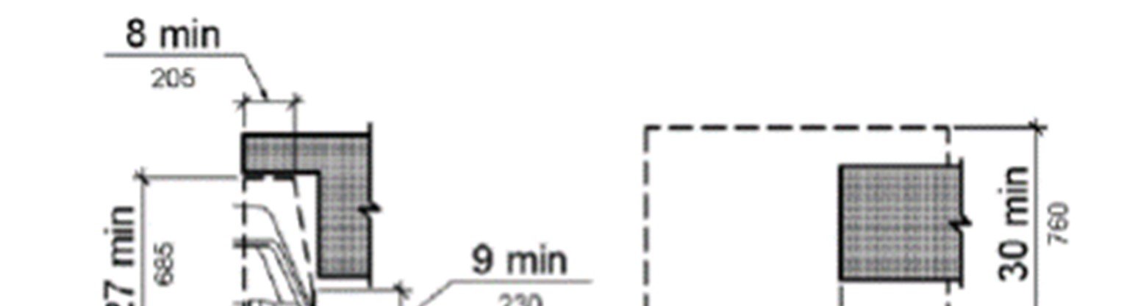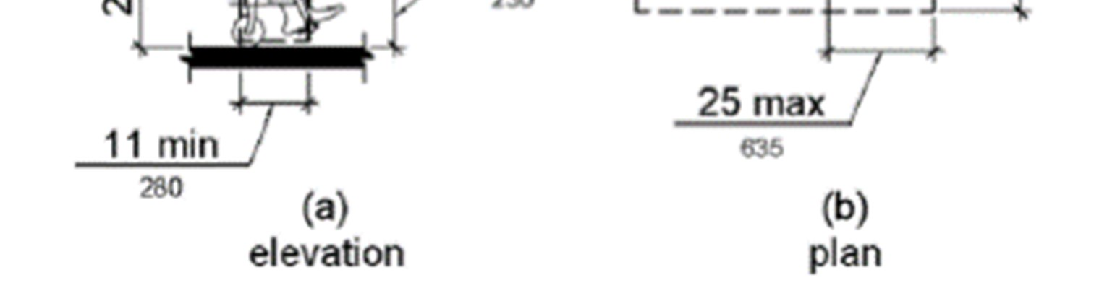

End of 2.5 San Diego Service Clinic Report

Accessibility Evaluation Reports

2.6 Falfurrias Service Clinic
Facility Location: | 101 W. Potts, Falfurrias, TX
Construction Date/Year: | 1996
Occupancy Status (Owner or Lease): | Owner
Accessibility Standards Reviewed:
- 1994 Texas Accessibility Standards (1994 TAS) o Referenced because the building was built prior to 2012.
- 1991 ADAAG (91 ADAAG)
o Referenced because the building was built prior to 2010.
2.6.1 Summary of Findings
Accessible site and building elements were reviewed based on the 1994 TAS. The elements below were identified as non-compliant and need to be addressed. Corrections to these items should be done according to the current 2012 Texas Accessibility Standards (2012 TAS). Compliant Items are not identified.

Accessible Approach / Accessible Entrance
- Parking. There is a total of 16 parking spaces serving the facility. The minimum number of required accessible spaces is one and shall be designated as van accessible.
There are currently two designated spaces, including a van accessible space.
  - Switch the designated spaces so the space with the access aisle to the right is the van accessible space. Relocate the existing “van accessible” sign as well. o Accessible parking spaces are permitted to share the accessible aisle(s).
  - If the striping is updated, then the pavement markings need to comply with TAC 68 Section 68.104. This Section and an example illustration are also attached for reference.
  - Signs are permitted to be attached to the building. If remounted to sign posts, then the new posts with the correct signage need to comply with Section 703.1.2 of the 2012 TAS. This section is included in the Appendices of this document.
  - Section 502 of the 2012 TAS for parking requirements is included in the Appendices of this document.
- Curb Ramps.
  - No comments.

Accessible to Goods and Services
- Signage. Provide interior and exterior signs to identify permanent rooms, accessible restrooms, and directional signs where necessary.
  - Signs and signs with pictograms shall comply with Section 703 of the 2012 TAS.
This section is included for reference to Provide tactile signs identifying emergency exits
  - Provide tactile signs with the International Symbol of Accessibility to identify accessible restrooms
  - Signs need to be mounted alongside the latch side (locking) side of a single door, where the baseline of the lowest text line is 48 inches maximum or the baseline of the uppermost text line 60 inches above the finished floor to ground level
▪ Mounting instructions for double door or inadequate room to the latch side of a door can be found in Section 703.
- Protruding Objects. o No comments. • Service Counters.
  - No comments.

Accessible Restrooms and Related Elements
The construction date of the original portion of the facility is unknown. The last addition was constructed in 1996. Per the 1994 TAS, Section 4.1.3 (11) Toilet Facilities: If toilet rooms are provided, then each public and common use (emphasis added) toilet room shall comply with 4.22. Other toilet rooms provided for the use of occupants of specific spaces (i.e., a private toilet room for the occupant of a private office) shall be adaptable. (Partial statement) The term “Public Use” and Common Use” are defined as follows under the 1994 TAS.
- Public Use: “Describes interior or exterior rooms or spaces that are made available to the general public. Public use may be provided at a building or facility that is privately or publicly owned”
- Common Use: “Refers to those interior and exterior rooms, spaces, or elements that are made available for the use of a restricted group of people (for example, occupants of a homeless shelter, the occupants of an office building, or the guests of such occupants).”
Based on this Section, the restrooms in the building addition should have been designed and constructed to be accessible. Each restroom was observed, and the common non-compliant elements are the following:
- Single Use Toilet Rooms. The small, single use restrooms in the original portion of the facility should not be identified as accessible though measures have been taken to make them as accessible as possible.
- Larger Toilet Rooms. The larger, gang style restrooms in the addition were observed and the following deficiencies were observed.
- Accessible Stall Doors. The accessible stall doors in both the larger men’s and women’s restrooms need self-closing hinges. Accessible stall doors are required to be self-closing in the 1994 and 2012 TAS.

- Water Closet Flush Controls. One accessible restroom stall has the flush control on the wrong side of the toilet bowl. The flush controls need to be on the open side of the water closet. The replacement control can be either hand operated or automatic. If hand operated, then the lever or paddle must be placed on the open side of the water closet.
- Toilet Tissue Dispensers. The toilet tissue dispensers for the accessible restroom stalls need to be adjusted to comply.
    - If new dispensers are being installed, or existing being adjusted, then the space between the grab bar and dispenser mounted below shall be 1 1/2 inches minimum. The space between the grab bar and the dispenser if mounted above the grab bar shall be 12 inches minimum. This is to make sure a person can still access the grab bar without interference.
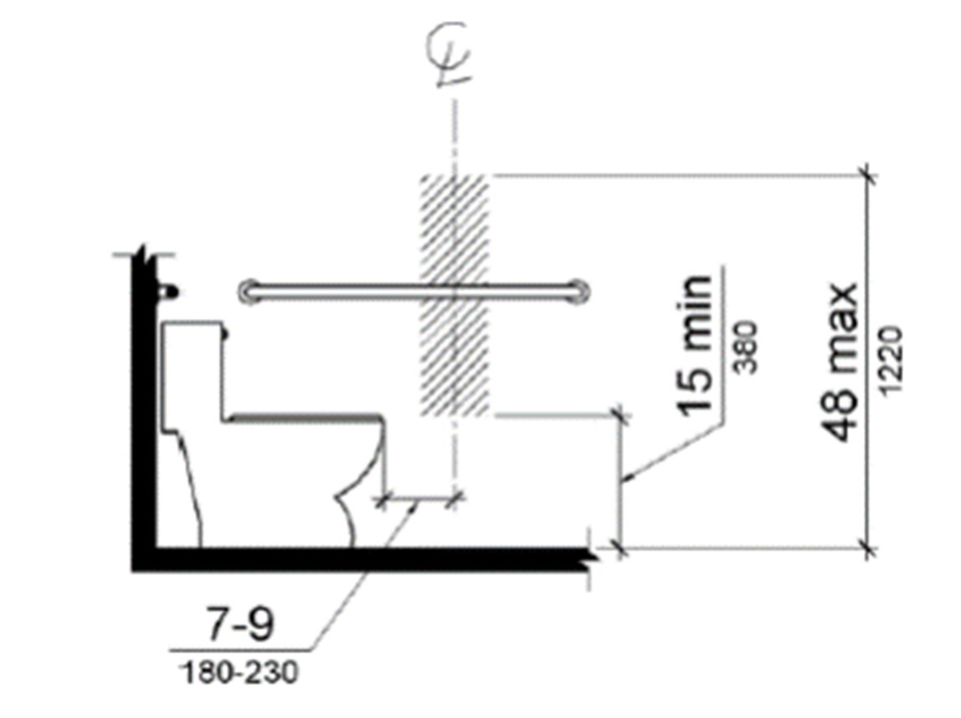
Figure 1 Dispenser outlet location zone

    - Toilet paper dispensers shall comply shall be mounted seven inches minimum and nine inches maximum in front of the water closet measured to the centerline of the dispenser. The outlet of the dispenser shall be 15 inches minimum and 48 inches maximum above the finish floor and shall not be located behind grab bars. The figure above illustrates the requirements.
    - The hatched zone in the figure is the zone for the toilet tissue dispenser outlet location (point where the paper is dispensed). If new dispensers are provided, they must not control delivery or not allow continuous paper flow. If a double roll dispenser is installed, the Standards do not state which outlet needs to be centered as described.
- Grab Bars. The grab bars on the parallel walls (42-inch bars) need to be adjusted so they are a minimum of 54 inches to the center of the leading flange from the wall behind the water closet. Maintain the same height (required range is 33 to 36 inches) to the top of the gripping surface as the rear mounted grab bars.
- Mirrors.
  - No comments
- Paper Towel Dispensers.
  - The women’s room paper towel dispenser is considered a protruding object in its current location. Relocate the dispenser so that is it does not interfere with the forward approach of either lavatory or approach to the restroom door.
- Lavatories.
  - No comments.

Additional Accessible Elements
- Fire Extinguishers. There are multiple fire extinguishers in the building held by a clip mounted to the surface of the wall. If they are in the path of travel, then the extinguishers should be relocated and mounted so that they are within the following reach ranges. o Where a forward reach is unobstructed, the high forward reach shall be 48 inches (1220 mm) maximum and the low forward reach shall be 15 inches (380 mm) minimum above the finish floor or ground.
  - Where a clear floor or ground space allows a parallel approach to an element and the side reach is unobstructed, the high side reach shall be 48 inches (1220 mm) maximum and the low side reach shall be 15 inches (380 mm) minimum above the finish floor or ground
  - If built-in or fixed obstructions are present that cannot readily be moved (such as furniture), please refer to Sections 308 of the 2012 TAS for more information on reach ranges.
  - For a further explanation on protruding objects, refer to Section 307 of the 2012 TAS.
- Sinks. A side approach to the kitchen/break room sink is permissible. However, consideration should be given to adjusting and protecting the exposed pipes to meet the required knee space, so the sink’s accessibility is increased.

End of 2.6 Falfurrias Service Clinic Report

Accessibility Evaluation Reports

2.7 Beeville Service Clinic
Facility Location: | 2808 Industrial Blvd, Beeville, TX
Construction Date/Year: | 2002
Occupancy Status (Owner or Lease): | Owner
Accessibility Standards Reviewed:
- 1994 Texas Accessibility Standards (1994 TAS) o Referenced because the building was built prior to 2012.
- 1991 ADAAG (91 ADAAG)
o Referenced because the building was built prior to 2010.

2.7.1 Summary of Findings
Accessible site and building elements were reviewed based on the 1994 TAS. The elements below were identified as non-compliant and need to be addressed. Corrections to these items should be done according to the current 2012 Texas Accessibility Standards (2012 TAS). Compliant Items are not identified.

Accessible Approach / Accessible Entrance
- Parking. There is a total of 51 angled parking spaces serving the facility. The minimum number of required accessible spaces is three with one designated as van accessible. Angled parking is permissible if the accessible spaces and aisles comply with the width dimensions in the TAS. There are currently two spaces designated as accessible.
    - Designate the accessible space with the existing access aisle to the right as the van accessible space with the correct signage and “van accessible” designator sign.
    - The second existing accessible space shall be clearly identified as an accessible space with the correct signage. Accessible parking spaces are permitted to share the accessible aisle(s).
    - The third accessible space will need both an access aisle to one side and the correct signage. The third space can be additional simple or van accessible space.
    - If a simple (not for a van) space is chosen, to reduce the amount of striping, consider laying out the space as a “universal” accessible space, where the parking space is 11 feet minimum in width with a five-foot accessible aisle to the right side of the vehicle. This type of accessible space can serve both a car and van.
    - If the striping is updated, then the pavement markings need to comply with TAC 68 Section 68.104. This Section and an example illustration are also attached for reference.
    - The new posts with the correct signage need to comply with Section 703.1.2 of the 2012 TAS. This section is included in the Appendix of this document. o Section 502 of the 2012 TAS for parking requirements is included in the Appendix of this document.
- Curb Ramps. The primary accessible ramp is similar in construction to one located at the clinic in Taft.
  - The lip of the primary accessible ramp at the aisle for the accessible spaces is greater than one-quarter of an inch (1/4”) vertical, which is non-compliant in both the 1194 and 2012 TAS. The current state may be contributed to natural settling.
▪ The transition between the parking lot access aisle and the base of the ramp shall be level for the length of the ramp.
  - The primary access ramp has the correct slope in the direction of travel, but the flares are not compliant with either the 1994 or 2012 TAS. The flares are not distinguishable from the surrounding pavement. The ramp should be outlined in a contrasting color to make is discernible for people with visual impairments. o the flares are not distinguishable from the surrounding pavement. The ramp should be outlined in a contrasting color to make is discernible with visual impairments.
  - A third ramp will be necessary for the third required accessible parking space. o the third ramp can be one that is integrated into the existing sidewalk that has a landing in line with the access aisle. An example of this type of ramp is the design in the Alice Clinic parking lot (See photo below).
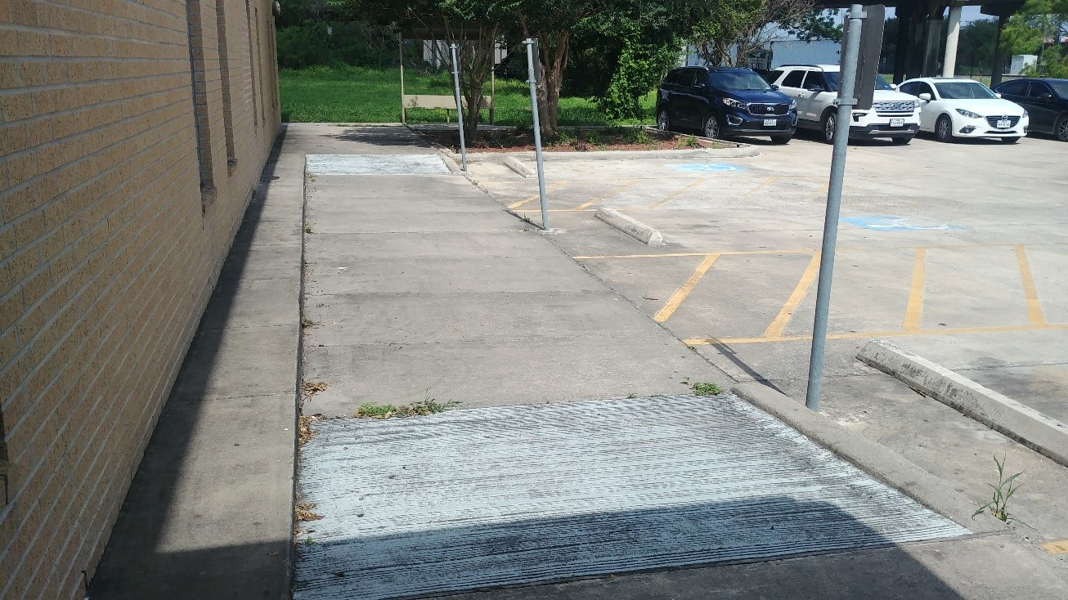

Landing at the same

level as
the parking lot
Ramp integrated
into the sidewalk
Figure 1: Photograph of the integrated ramp at the Alice Clinic

Accessible to Goods and Services
- Signage. Provide interior and exterior signs to identify permanent rooms, accessible restrooms, and directional signs where necessary.
  - Signs and signs with pictograms shall comply with Section 703 of the 2012 TAS.
This section is included for reference to Provide tactile signs identifying emergency exits
  - Provide tactile signs with the International Symbol of Accessibility to identify accessible restrooms
  - Signs need to be mounted alongside the latch side (locking) side of a single door, where the baseline of the lowest text line is 48 inches maximum or the baseline of the uppermost text line 60 inches above the finished floor to ground level
▪ Mounting instructions for double door or inadequate room to the latch side of a door scenarios can be found in Section 703.
  - The current public restroom signs are mounted on the doors. The signs need to be relocated to the latch side of the doors.
- Entrance Landing/Porch. Due to suspected settling of the approaching sidewalks, the resulting lip at the landing and sidewalk junction has grown to more than one-quarter inch (1/4”). A grout material has been used to form inclines to make the edges accessible.
  - If the inclines on both sides of the porch landing are replaced, then the slope of the inclines shall be 1:12 (8-8.3%), or
  - If the section of sidewalk on both sides of the porch landing are replaced, then the running slope (direction of travel) of the walkway shall be 1:20 and the cross slope (slope perpendicular to the direction of travel) shall be 1:48, or 5%.
- Protruding Objects. Elements extending out four inches or more from the wall surface constitute a protruding object. The mail/document collection baskets mounted to the wall by each of the offices do not extend out further than four inches (4”) from the wall therefore are not a violation. However, should a person in a wheelchair become an employee, consider lowering these baskets to within the following reach ranges to make them accessible.
  - Where a forward reach is unobstructed, the high forward reach shall be 48 inches maximum, and the low forward reach shall be 15 inches minimum above the finish floor or ground.
  - Where a clear floor or ground space allows a parallel approach to an element and the side reach is unobstructed, the high side reach shall be 48 inches maximum, and the low side reach shall be 15 inches minimum above the finish floor or ground
  - If built-in or fixed obstructions are present that cannot readily be moved (such as furniture), please refer to Sections 308 of the 2012 TAS for more information on reach ranges.
  - For a further explanation on protruding objects, refer to Section 307 of the 2012 TAS.
  - If the current basket locations will interfere with the new room identification signs, compliance with the sign mounting requirements should take precedence.
- Service Counters. The service counter at the front desk window extends outward beyond the four-inch limitation for a protruding object given their height without any means below them to be detected by a walking cane. The counter can either be removed and replaced with a piece of furniture to provide the same convenience, or a means that extends to the floor so that the counter is detectable can be installed.

Accessible Restrooms and Related Elements
Per the 1994 TAS, Section 4.1.3 (11) Toilet Facilities: If toilet rooms are provided, then each public and common use (emphasis added) toilet room shall comply with 4.22. Other toilet rooms provided for the use of occupants of specific spaces (i.e., a private toilet room for the occupant of a private office) shall be adaptable. (Partial statement)
The term “Public Use” and Common Use” are defined as follows under the 1994 TAS.
- Public Use: “Describes interior or exterior rooms or spaces that are made available to the general public. Public use may be provided at a building or facility that is privately or publicly owned”
- Common Use: “Refers to those interior and exterior rooms, spaces, or elements that are made available for the use of a restricted group of people (for example, occupants of a homeless shelter, the occupants of an office building, or the guests of such occupants).”
Based on this Section, the restrooms in the building addition should have been designed and constructed to be accessible. Each restroom was observed, and the common non-compliant elements are the following:
- Water Closet Flush Controls. Several restroom toilets have the flush control on the incorrect side of the toilet bowl. The flush controls need to be on the open side of the water closet. The replacement control can be either hand operated or automatic. If hand operated, then the lever or paddle must be placed on the open side of the water closet.
- Toilet Tissue Dispensers. The toilet tissue dispensers for the accessible restroom stalls need to be adjusted to comply.

(Next page)
If new dispensers are being installed, or existing being adjusted, then the space between the grab bar and dispenser mounted below shall be 1 1/2 inches minimum. The space between the grab bar and the dispenser if mounted above the grab bar shall be 12 inches minimum. This is to make sure a person can still access the grab bar without interference.
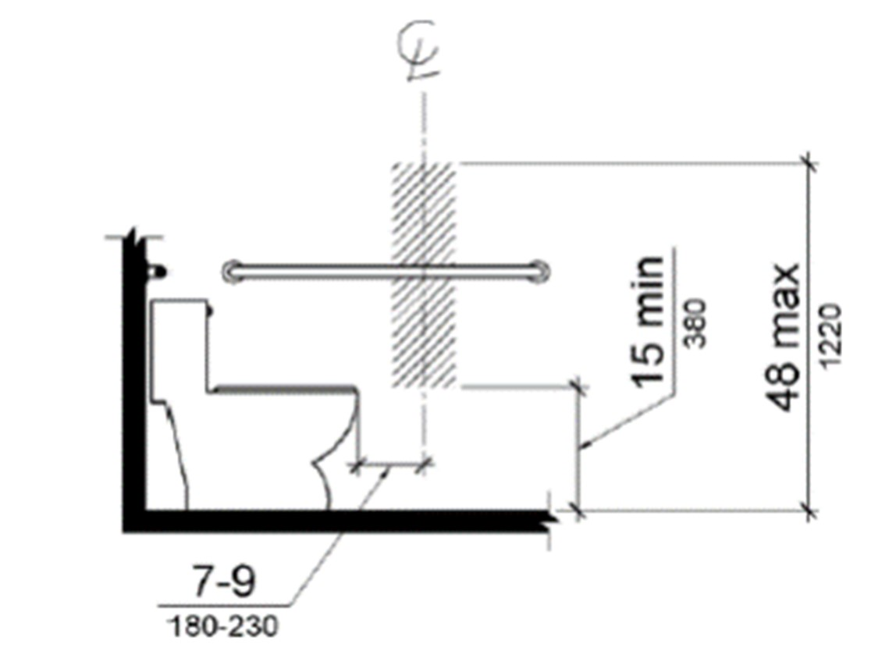
Figure 2 Dispenser outlet location zone

    - Toilet paper dispensers shall comply shall be mounted seven inches minimum and nine inches maximum in front of the water closet measured to the centerline of the dispenser. The outlet of the dispenser shall be 15 inches minimum and 48 inches maximum above the finish floor and shall not be located behind grab bars. The figure above illustrates the requirements.
    - The hatched zone in the figure is the zone for the toilet tissue dispenser outlet location (point where the paper is dispensed). If new dispensers are provided, they must not control delivery or not allow continuous paper flow. If a double roll dispenser is installed, the Standards do not state which outlet needs to be centered as described.
- Grab Bars. The grab bars provided in the public access restrooms are not the correct sizes. The grab bars on the parallel walls need to be 42 inches in length minimum and installed so they are a minimum of 54 inches to the center of the leading flange from the wall behind the water closet. The grab bars for the wall behind the water closet shall be 36 inches in length, where the flange of the bar oriented towards the wall is 12 inches on center from the centerline of the water closet.
  - If certain bars are the correct size but located in the incorrect place, the existing bars can simply be relocated.
  - Maintain the same height (required range is 33 to 36 inches) to the top of the gripping surface as before.
  - Grab bars above the urinals are not required but need not be removed. o Grab bars near the lavatories are not required but need not be removed.
- Mirrors. The restroom mirrors do not comply with the 1994 Standards, which states that the bottom of the reflective surface – not the frame of the mirror - shall be mounted 40 inches maximum above the finished floor. This measurement is the same for the 2012 TAS. The mirrors need to be adjusted so that the mounting height from the finished floor to the bottom of the reflective surface is correct.
  - The 1994 TAS also states that if one mirror is serving the restroom, then it the topmost edge shall measure at least 74 inches high. A mirror that is 36 inches in overall height mounted above a lavatory would meet the topmost edge minimum in the 1994 Standards. The 2012 TAS only advises that the topmost edge measure at a minimum of 74 inches above the finished floor.
  - The 2012 TAS also states that a large, full length mirror mounted on the wall with the bottom of the reflective surface at 35 inches maximum above the finished floor is permitted. If this option is chosen, then it is suggested that the full-length mirror comply with the topmost edge advisement when installed.
- Paper Towel Dispensers.
  - The women’s room paper towel dispenser is considered a protruding object in its current location. Relocate the dispenser so that is it does not interfere with the forward approach of either lavatory or approach to the restroom door.
- Lavatories. Not all of the exposed piping of the wall hung lavatories in the restrooms are not protected as required. The drainpipe, water lines and valves must be protected as required both in the 1994 and 2012 TAS. Additional Accessible Elements
- Fire Extinguishers. There are multiple fire extinguishers in the building held by a clip mounted to the surface of the wall. If they are in the path of travel, then the extinguishers should be relocated and mounted so that they are within the following reach ranges. o Where a forward reach is unobstructed, the high forward reach shall be 48 inches maximum, and the low forward reach shall be 15 inches minimum above the finish floor or ground.
    - Where a clear floor or ground space allows a parallel approach to an element and the side reach is unobstructed, the high side reach shall be 48 inches maximum, and the low side reach shall be 15 inches minimum above the finish floor or ground
    - If built-in or fixed obstructions are present that cannot readily be moved (such as furniture), please refer to Sections 308 of the 2012 TAS for more information on reach ranges.
    - For a further explanation on protruding objects, refer to Section 307 of the 2012 TAS.
- Sinks. A side approach to the kitchen/break room sink is permissible. However, consideration should be given to adjusting and protecting the exposed pipes to meet the required knee space, so the sink’s accessibility is increased.
- Emergency Exit(s). The emergency exits of the building do not have the correct clear floor space for a forward approach to the door.
The 1994 TAS state that: “4.1.3(8)(ii) Accessible entrances and exits must be provided in a number and at locations at least equivalent to the total number and locations of exits required by the applicable building/fire codes, including accessible routes. Refer to 4.1.3(9) where conditions preclude accessible exits.”
(1994 TAS, Partial statement) Not all exit doors meet the forward approach clearance. Where the door swing can be changed, the door needs to be reversed so that the latch side of the door has the correct clearance for a forward approach, which is 12 inches minimum. The exit door(s) must still swing outward. See the figure below for the floor clearance requirements (from 2012 TAS, Section 404.2.4.1).
    - The outside landing at the exist will need to be modified so that the finished floor level is the same as the interior floor. The slope in the direction of travel in the landing shall not exceed 1:20.
    - The door threshold shall also be modified so that the height is not greater than 1/2 of an inch.
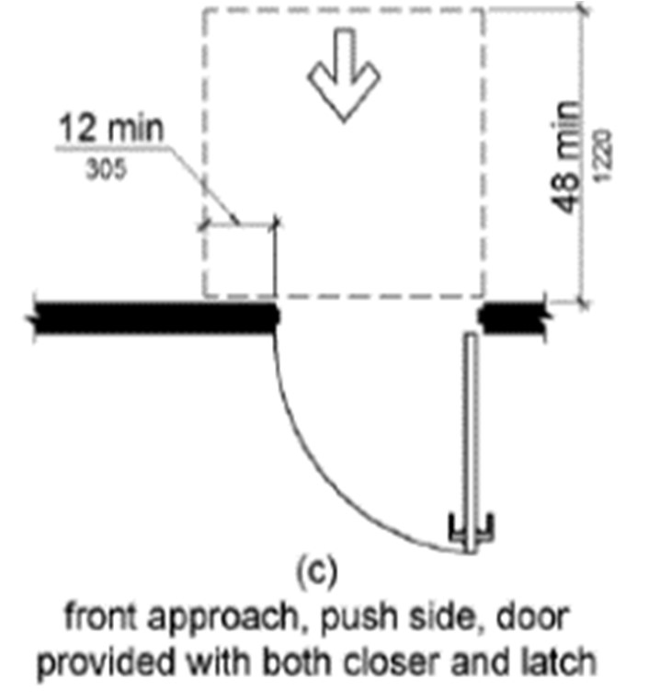

End of 2.7 Beeville Service Clinic Report
(B) If non-structural changes cannot achieve program accessibility, place the feature on your transition plan for necessary structural changes (see Section “L”). Responsible parties: Risk Management Specialist.

Plan of Action/Plan of Correction – by Site
Site # | Site | Accessibility Issue(s) | Action to be taken |  | Completion Date
1 | Kingsville Clinic DIDD | Signage- not in compliance with 212- 703. | Signage corrected |  | Feb.4th, 213. Notice of compliance RAS Sue Corey
2 | Rockport children’s clinic | None | N/A |  | Passed 11/26/18 Sue Corey
3 | Alice Clinic DIDD | Alice constructed in 2008 by Teal Contractors’. Barrier free design executed by Farrera Architects CC TX. Inspected with 2012 standards. No grandfathering given. Non-c compliance issues: 1) Signage did not conform to section 703. 2)Bathroom fixtures – placement not to standards 3) Drinking fountain protrusion beyond 4” max. |  | Signage obtained from CC Stamp works and installed on Oct. 20,2021 Bathroom fixtures were removed and re-positioned according to measurements outline by RAS specialist Alcoves for water fountains remodeled to comply with 4’ setbacks. | This Facility was inspected by HHS inspector and passed to provide for SUD program on 10/2/21. Ras inspection followed on11/23/21 noted that “all citations were corrected
4  5 | Portland administrative offices  Taft | Portland was constructed in 2001. The standards which apply are the 1994 Texas accessibility standards. Non -compliance issues; 1) signage was not to 2012 standards 2) grab bars were not the 54” from back wall 3) Toilet paper dispensers mounted in wrong position 4) Mirrors were hung a ½ inch too high above lavatory with liquid nail. Removal would destroy wall finish.  Taft was constructed in 2001 on lease to purchase by Judy Co. CPCC purchased the property in 2008.  The property was inspected by a RAS inspector and many issues were cited as noncompliant as stated in the 2012 TAS. Due to the age of the building (2001) there should be grand fathering to the 1997 standards. |  | 1) Signage was purchased and installed in compliance with 2012 & 73 TAS. 2) existing grab bars were removed and replaced with proper length to meet the 54 Inch standard.  3) toilet paper dispensers removed and replaced by standard one roll fixtures.  4) Full length mirrors were added that were hung in compliance with standards for wheel chair bound individuals. Completed Jan 2022.  CPCC will attempt to modify fixtures, signage and other attributes to comply with the 2112 TAS where economically feasible. Work will begin on the parking area, to include standards and signs to designate handicapped parking. striping of van access and the wheel chair ramp to finish. A false wall will be constructed in the restroom to fill the gap between the wall and toilet. | Remedial work was initiated June of 2021. Project completion estimated Jan. 2022  All cititions where addressed and completed by Coastal Plains Community Center December 2022  Work to begin in March of FY 2022.  All citations where addressed and completed by Coastal Plains Community Center  March 2023
6 | Aransas pass | The Aransas pass clinic is a rental building. Parking is in short supply, shared with other tenants. As noted in the inspection report the van access is reversed. Restroom areas are not currently in compliance with the 2012 standards. The new addition, constructed by coastal plains has accessible toilets. Signage to direct public to the accessible toilets will be posted temporarily until the restrooms closest to the weight room can be remodeled. |  | Parking will have proper signage and striping to extent possible. Interior signage to be compliant with 2012 TAS. Bathrooms in the reception area to be made wheelchair accessible | Upon completion of Taft, projected to begin July 2023
7 | Falfurrias MH Clinic | Falfurrias MH clinic was constructed by Brooks county in 1998 and was offered as “in- kind” to coastal plains in leu of monetary matching contribution. The center purchased the building in 2114 when the county decided to asses rent of 50K per year. CPCC will be required to properly stripe and designate parking, designate the two main restrooms as “public restrooms” and bring them to compliance, post interior signage consistent with 2012 TAS, |  | Parking striping and signage shall be ADA compliant. Bathroom fixtures shall be mounted in a compliant fashion. Signage in the building shall direct public to the accessible restroom areas. | July – Sept 2023
8 | Beeville | Beeville was constructed in by Judy Co. for Coastal plains. The parking lot has had numerous re-finishes to include sealant. Parking designation and striping needs to delineate handicapped spaces and van accessible space. Ramp requires yellow striping to delineate incline at sides. The entrance landing was part of the slab poor and has remained stable. The sidewalk has settled creating a ½ inch drop making the front entrance not wheelchair accessible. Interior signage is non-compliant with 2012 TAS. Restrooms are not compliant due to grab bar issues, flush control, toilet paper dispenser issues, mirrors, and sink plumbing is not covered. |  | Handicapped parking requires striping and appropriate signage. Additional asphalt to fill gap to parking lot. The ramp must be properly painted to delineate the wings of the approach. The sidewalk needs demo on one side of the approach and re-pored to address the settling issue. That side will be designated the handicap approach. Bathroom fixtures (toilets) in the front two restrooms need to be compliant and designated W/C accessible. Grab bars will be appropriate lengths. These will serve as public restrooms. Remaining bathrooms will be designated “common “facilities and will not bear the W/C signage | Begin Jan 2023.

3. List steps to ensure that all future construction and renovation work will comply with the architectural and accessibility standards (exclude projects managed by Central Office Maintenance and Construction).

All contracts for facilities will refer to the “Texas Accessibility Standards” as the construction standard for ADA reference.

4. List steps to ensure periodic communications with (potential) disabled program participants concerning accessible and inaccessible facilities.

All program participants by definition are disabled. Service Coordinators and other staff make participants aware of accessibility issues to include accessible restroom (toilet) facilities.

5. Is the facility in question considered “historic” (e.g., is it either on the National Register of Historic Places or on a state or local list of historic places)?

X | No |  |  | Yes

If yes, list steps to ensure program accessibility, including any structural changes. If structural changes would compromise the historic value, list alternative methods to ensure program accessibility. (Note: Only those programs that uniquely concern the preservation and experience of the historic property itself are covered by this exemption. If the program held at a historic facility is not a “historic preservation” program, it must be relocated if structural accessibility is not possible.)

J. Employment

1. List safeguards in place to ensure that all employment decisions are made without discrimination on the basis of disability, and that such decisions do not limit, segregate or classify applicants or employees based on disability in a way that adversely affects their employment opportunities or status.

(a) All position vacancies are posted and advertised in countywide publication, job phone line for non-sighted potential applicants.
(b) Interviews conducted with prepared questions, which are reviewed by HR prior to interviews for EEO issues.
(c) Staff are trained in proper interview techniques to include ADA issues involving selection process.

2. Are you participating in a contractual or other arrangement or relationship that subjects qualified applicants or employees with a disability to discrimination (i.e., relationships with employment or referral agencies, labor unions, or organizations that provide fringe benefits, training, or apprenticeship programs)?

X | No |  |  | Yes

If yes, list steps to be taken to ensure non-discrimination in the future.

3. Analyze the following aspects of employment to make certain that no discrimination based on disability exists (including discrimination which occurs due to an inaccessible facility):

Recruiting, advertising and processing applications for employment; NONE
Hiring, upgrading, promotion, award of tenure, demotion, transfer, layoff, termination, right of return from layoff, and rehiring; NONE
Rates of pay or another form of compensation and changes in compensation; NONE
Job assignments, job classifications, organizational structures, position descriptions, lines of progression, and seniority lists; NONE
All forms of leave; NONE
Equal benefits and privileges available by virtue of employment, whether or not administered by the recipient; NONE
Selection and financial support for training, including apprenticeship, professional meetings, conferences and other related activities, and selection for leaves of absence to pursue training; NONE
Employer-sponsored activities, including social and recreational programs; NONE and,
Any other term, condition or privilege of employment. NONE

4. Do you have a policy concerning “reasonable accommodation” that specifies the decision-making process for identifying, arranging for and/or paying for, and determining undue hardship for reasonable accommodation?

 | No |  | X | Yes

If no, list steps to be taken to establish a reasonable accommodation policy.

Coastal Plains Community Center will abide by the established Texas Administrative Code and HHSC's policy regarding accommodations for disabled employees.

5. What employment tests or criteria are used for evaluating potential employees? Describe procedures to ensure that these criteria or tests do not discriminate against disabled persons, unless they are shown to be consistent with job necessity and are directly related to the essential functions of the position.

(a) Criminal records - no adverse impact
(b) Drug screening - no adverse impact
(c) Interview and selection process consistent with HHSC methodology - no adverse impact
(d) CANRS - no adverse impact
(e) Driving History - job necessity

6. Describe methods to identify the job-related characteristics of tests and criteria used in employment decisions.

(a) Job analysis identifies essential and non-essential job tasks.
(b) Test and interview methodology related directly to position description and identified essential elements.

7. Describe steps to ensure that no pre-employment inquiries are made as to whether ran applicant is a disabled person or as to the nature or severity of a disability. (Inquires related to one’s ability to perform the essential functions of a job effectively and safely are permitted.)

(a) Application contains no pre-offer inquiries.
(b) All interrogatories approved by Human Resources EEO officer.
(c) All interrogatories related specifically to essential elements of position description.

8. Does your organization conduct or require any medical exams or physical capacity assessments prior to making final offers of employment?

X | No |  |  | Yes

If yes, describe procedures to ensure that a) all entering employees are subject to medical exams, b) all offers of employment are conditional based on the results of the exams, c) the medical results gathered are not used in a discriminatory manner, and d) all information gathered is kept confidential. Pre-employment medical examination before conditional job offers are not permitted.

9. Review job application forms and interview questions to ensure that applicants are not asked about the existence of (or nature of severity of) a disability. You are allowed to inquire about the candidate’s ability to perform job functions. Ensure that applicants are not asked about their relationship or association with a disabled individual.

Such review is conducted by Human Resources EEO officer prior to interview by hiring authority.

10. Review the essential and marginal functions of existing positions descriptions for each position in your organization for use in determining what makes applicants “qualified” and what job accommodations can be made when necessary for an applicant or employee.

Each position description is based on job analysis, which identifies essential and nonessential functions of the position. Requests for accommodations are reviewed on an individual basis with determinations made based on cost and facility's ability to provide the requested accommodation.

11. Describe the process used to determine the essential and marginal tasks of positions descriptions in your organization and the process for ensuring that position descriptions are kept current.

Each job posting requires a review by the hiring authority. New positions require job analysis. Positions are updated as functions are modified or changed.

K. Communications

1. Provision of Auxiliary Aids
List auxiliary aids that are available (or sources where they can be obtained) for individuals with speech, vision or hearing impairments. This can include qualified readers and interpreters, taped, brailed or large-print materials, or closed-captioned video programs.
a) Readers
b) Interpreters
c) Phone access for vision impaired
d) Written materials
e) Specialized communication devices such as light talkers, etc.
f) Sign Language services for people with hearing impairments

2. Are auxiliary aids provided to individuals with hearing, speech or vision impairments when needed to ensure effective participation in a program or activity? If no, list steps to ensure that auxiliary aids are provided to overcome communication barriers.

Yes - Specialized therapy providers assess individual needs to ameliorate disabilities.

3. Telecommunication Devices for the Deaf
Does the public entity provide services or information to the general public over the telephone?
 | No |  | X | Yes

If yes, is a telecommunication device for the deaf (TDD) or other equally effective system available so that public entities can communicate with hearing-impaired and speech-impaired individuals?

 | No |  | X | Yes

If no, list steps to ensure effective communications with hearing-impaired and speech-impaired individuals. This can include providing a TDD or relying on a third-party relay service. Note: The Justice Department encourages entities that have extensive phone contact with the public to have TDDs to assure more immediate access.

a) The Center utilizes the TDD services available through Deaf Interpreter Services
b) Coastal Plains Community Center has access to a web site, which will provide list of services, sites and accessibility information.

4. Information and Signage
Is information provided concerning the following? Yes

Signage at inaccessible entrances directing people to an accessible
entrance or a location with information about an accessible entrance.

All sites have been reviewed for accessibility signage and individual site plans have been implemented to post accessibility signage. Coastal Plains will continue to use the A.D.A. inspection tool on a yearly basis to ensure signage remains posted.

Signage directing people to elevators and stairways:

Coastal Plains has no elevators or stairways

Signage concerning the availability and location of TDD equipped pay phones or portable TDD’s.
Coastal Plains is posting Information Brochures providing user information about “Relay Texas” services. Also, we have completed an Employee awareness training to address needs of hearing-impaired persons.

Signage should comply with 4.30 of the Texas Accessibility Standards and the ADA Accessibility Guidelines.
See transition plan table beginning on pages 14 & 15 of this plan.

